TIPS AND HUSBANDRY NOTES

TIPS AND HUSBANDRY NOTES
(Click on number to move to page)
A BASIC HOME 1
FOR PET OR BREEDING FEMALES 1
FOR MALES 2
A GOOD HOME FOR ALPACAS 3
TRANSPORT 4
ALPACAS AS PETS 5
ALPACAS AND DOGS 7
SET-UP 8
TEMPERAMENT 9
THE LAND, THE PASTURE, THE ANIMALS 13
CONDITION 14
SIZE 15
FEEDING 16
FEEDING CRIAS 18
PARASITES 20
RECORDS 21
STRESS 22
OLDER PERSONS 24
BREEDING GREYS 25
GREY, TUXEDO, MULTI, AND BLUE-EYED WHITE 25
GREY AND ROAN 26
GREY PLUS TUXEDO EQUALS CLASSIC GREY? 31
BREEDING CLASSIC GREY 32
IMPROVEMENT 33
BIRTHS 36
FLAWS 38
FEEDING A CRIA 39
WEANING 40
HALTER TRAINING 41
RAISING HAPPY, HEALTHY ALPACAS 42
COATS 44
MEDICAL MATTERS 47
SELECTION and ENVIRONMENT 49
ENVIRONMENT 49
AGE AND DEVELOPMENT 50
BREEDING HERE: some examples from one female line 52
CHOOSING YOUR ANIMALS 56
SHOWING AND BREEDING 57
THE PRODUCT 59
FINALLY 60

TIPS AND HUSBANDRY NOTES
What follows is offered only as of possible interest and is not supposed to replace veterinary advice. Nor is it meant to suggest criticism if you are doing something else. We learned as we went, so some of this advice is from experience of having done things that weren't a good idea. Every property is different.

A BASIC HOME

FOR PET OR BREEDING FEMALES
Caring people, observant and willing to learn, with sufficient money to be able to care for their animals and to buy hay through a drought, in winter, in bad weather, and after shearing.

It is unwise to buy cheap female alpacas because you cannot afford them unless they are cheap and then find yourself unable to feed them appropriately or upset by the costs.

Breeding females are more work to look after and cost more to maintain than males or non-breeding females. Things happen. Your first birth might require vet help on a Sunday. Crias are wonderful, but they, too, need attention.

You should have enough females for company (at least 3 or 4 mature females) on sufficient land (at least 3 acres just for three females), with safe fencing, without obvious danger from dogs, with pasture, with shade, and with shelter. If you are breeding, more acres will be essential in time. More animals are better—four is small. Six is better, eight is better still, and with twenty adult females your herd will be comfortable.

It is fun to buy alpacas, but it is all too easy to get excited and buy some then shift focus and buy a different sort, then another, and then find you have too many for your property.

The paddock should have a safe place to catch the animals (gates in a corner secured to droppers will do, loose hinge joint won't do). If you are breeding, there should be another paddock for weanling males. Remember, you will have male crias and you really can't leave them permanently with the females. If there is a mature entire male he needs to be safely confined. (This is likely to mean double fence between him and females. A mature entire male usually cannot live with weanlings.) It is unwise to run a mature entire male with females who are giving birth or with females too young to be bred. Fencing should be six or seven strand plain wire, stretched, or some sort of mesh or hinge joint, stretched.

Alpacas do not normally challenge fences, but they can wiggle under six inches and jump over a barrier more than five feet high from a standstill. They do learn from each other. Electric fence does not impress them and also should not be used in a birthing area.

More space is better. It is healthier for the animals and less work for you.

Owners should be aware of the need for vaccination with 5-in-1 twice a year with breeding females, twice for crias (at around 6 weeks and 10 weeks, depending on your agreement with your vet) and shearing once a year. Vitamin D supplementation, at least for crias, is advised for southern areas. It is particularly important in drought. In drought the ADE with lower D may be helpful with mating and conception.

Shelter after shearing: good natural shelter is enough in many areas, but consider putting the animals overnight in a structure such as a garage if bad weather comes in. Alpacas generally do not use shelter at night and in very bad weather after shearing they need to be locked into their shelter. Somewhere dry to put feed in bad weather and rain is a good idea if you are not going to be home. Remember that the animals tend to want to be together, so even if you have shelter for two groups, if they can be closer to each other outside the shelters they are more likely to stay outside.

Owners should check with neighbours and vet about conditions. If you are likely to find toxic plants, liver fluke, ticks, or barber's pole worms on your property you need to form a strategy for control. If you have other livestock or frequent introductions you need to be more vigilant. Testing each introduction before drenching, so that you know which worms are present, and then at 10 days and again later is a good idea.

You do need to observe your animals or understand that there are risks in not doing so. Although much of the time nothing goes wrong, if there is an eye injury or an animal has squeezed under a fence into a laneway and has no water, checking them only weekly could leave you with a serious problem.

If you are not naturally observant then make an observation plan that allows you to see the animals in such a way that anything wrong is more obvious.

Mixing different livestock—alpacas with sheep, goats, and other farm animals–is attractive but be aware that this creates more work and more risk due to parasites and animal intereactions.

FOR MALES
Most of what applies to females also applies to males, but there are a few differences. Owning just males is less demanding that owning females. You need at least 2 males on at least 1/2 acre for the alpacas, and, as long as they are not severely challenged, the 5-in-1 can probably be just once a year.

A GOOD HOME FOR ALPACAS

This is more than a basic home. No property is ideal, so don't feel guilty if you can't do this.

Your female herd should be at least twenty head of adults, with young and crias extra. They should have at least 30 acres, and the total number, including crias, should be no more than around 2.5 animals per acre even if the pasture supports more. Alpacas spend their days doing different things in different places. Being required to eat, sleep, nurse crias and defecate in the same small area is a hardship for them. You should have at least two paddocks of at least 30 acres. The second is for an emergency. You can have a group of mature males on one, but you can't swap paddocks frequently. Each paddock should ideally have its own access to sheds and yards. This is because of parasites. At some point you could have a problem and need to drench and move your female herd. This is when that little area near where you handle or feed your animals becomes a hazard, because you have to re-use it after the drench. This is something you cannot safely do.

You also need small paddocks that have access to shelter, shade, yards and shed, and your house. You need more than one of these small paddocks. Remember that the small paddocks may be contaminated with worms easily.

We think it is safest to visit your expectant mothers regularly but leave them with the herd to after the birth, then later that day bring the mother and cria back to a smaller paddock where you can observe them for ten days to two weeks. But most people use a birthing paddock. This will be an area close to your house, with shelter and water and shade. An area like this gets a lot of use.

You need facilities for your weanlings--a clean, safe paddock.

You need facilities for a sick animal or you need to improvise something at the time. Portable panels might help. We once had animals in the laundry, and other people have had a similar experience. Even your van can be useful. A stable is useful.

Your mature entire males, once checked for parasites, can live in the empty one of your 30-acre paddocks, but somewhere else, farther from the females, may be easier.

In some locations you need to be able to shelter ALL your animals at once after shearing. You may only need this once in your time with alpacas, but you'll be glad.

TRANSPORT

Transport should be in a completely enclosed horse or alpaca float or van. Animals have been known to jump out the top space behind. They have tried to jump through the side windows on a standard horse float. They can jump a barrier of over five feet from a standing start, without warning, so fast that you don't see it happen.

An enclosed trailer is possible, but it must be completely enclosed, with a roof, high enough for animals to stand, have non-slip flooring (such as old carpet or rubber), and ventilation. If making a long journey or carrying pregnant females, you need several inches of straw or hay (after packing down). To get the right amount of straw don't break up the biscuits but pull them slightly apart side to side and tile them. Double axle gives a smoother ride than single. If you have a float, check the person-door. Often the latches on these are poor and have been known to open in transit, spilling alpacas onto the highway.

National guidelines for livestock transport suggest that alpacas can be carried in a stock crate, with non-slip floor, on a truck. This is possible, but consider conditions. If you are travelling on unsealed roads, in high heat, in cold, or with a single or pregnant animal, consider the risk. Putting a plastic tarp on the top of a cage trailer without a roof is not adequate for a long journey on major highways in the middle of winter.

If you are transporting entire males and females they need to be separated. If you are transporting mothers and crias they need time every two hours to stand up and allow nursing. You should avoid transporting crias under one month old in a crowded vehicle.

Although alpacas get through many journeys without mishap, things do happen in the vehicle, when getting out of the vehicle, and due to transport.

If you are considering how you will transport your alpacas you will have to decide between some sort of float or trailer and a van. After borrowing our neighbours' horse float for a couple of years we opted for a van, but there are just two of us and it is okay to have the van as our sole vehicle. It is nice because we know how the alpacas are traveling, and we are happier traveling with them. But the small vans, which can go in regular parking spaces and underground lots, only carry a few alpacas and only two people. If you are showing seriously and need to take more than four (young) animals to a show or to take a mature male as well as others, then you need a large van, probably in addition to your normal car, or a float.

The cost of transport is high, so if you are starting with a number of low-cost animals it is certainly natural to want to keep costs appropriate. However, it may be difficult to do this.

ALPACAS AS PETS

Alpacas are engaging animals that are pleasant to look at as they wander around your property.

We have had calls from people wanting a female and an entire male to run together. This is not a good idea. It is possible to have wethers and females together, but it may be easier to manage even wethers separately.

Usually, males will be suggested as pets. Some people feel they prefer generally to have female animals as pets, but it should be noted that alpaca females are not gentler with people than males are.

It is true that males are stronger. They also relate to each other and to people more. They fight with each other from a few days of age and prefer male crias for company. They can get quite noisy when they fight, screaming at each other even when not doing more.

Males fight less when castrated. The veterinary cost may be similar to that of castrating dogs and cats. If you are keeping male alpacas as guards with other livestock it is safest to have them castrated. A mature male might be fine with ewes, and there is some evidence that mature males guard better than wethers, but you need to weigh up the risks.

Most males will kick when in close quarters with other males. Some kick you even when there are no other males in the area. Many females will also kick you, especially when pregnant.

It is okay to buy some females and have a few crias for pleasure. But many people have problems early on. Some of these may be due to stress caused by movement and by the alpacas being in a small group. These will lessen over time. However, if you are working full time and gone in the day, you will eventually have some difficulty with your breeding females. A problem birth, easily fixed if you were there, can turn into a disaster in eight hours. If you have a slow cria and are not there on a hot day or a cold day your sleepy cria may not survive. Some crias, especially if premature, may not thermoregulate properly and can get cold or over-heated easily. Serious birthing difficulties can show up in any female of any age, but maidens are more at risk of minor difficulties that can be easily fixed.

You should expect:
1 of ten experienced dams and 2 out of ten maidens to need assistance at birth,
1 of ten dams to need attention in the two weeks following birth,
2 of ten crias of experienced dams and 3 of ten crias of maidens to need some help, however minor, on the day of birth,
1 of ten crias to need some attention in two weeks following birth,
All crias to need some attention in bad weather.
The problems mentioned above may right themselves without intervention, but, on the other hand, there might be more work later if they are not attended to at the time.

If you have only a few females you may go several years without a problem, but then again you might have several problems right away and then none for several years, so the average risk is not a protection.

Although you may want to have a cria or two for the children's pleasure and want to ensure there is nothing wrong with the animals you buy so that all is good and fun, things do happen, and the perfect animal may be less perfect in time.

Occasionally females when not mated can come to think they are pregnant when they are not. In my admittedly small experience these females have been even less good-tempered than when actually pregnant. Some females when open, or even when pregnant, will start mounting other open females. This is tiresome.

If you are buying alpacas as pets this means that they are indeed pets, to be cared for. A nice, halter-trained alpaca will cost a breeder quite a bit more to produce than the price you are likely to be paying. If you feel you must have females, consider a couple of older females who haven't been breeding in a while. Buying young females thinking you would like maybe to mate them sometime may not work out. Females who are not mated for some years can be hard or impossible to mate successfully even for an experienced breeder.

Often buyers want the youngest animals they can get so that the animals will bond to them and have a personal tie with them. The bonding, though, is on the human side. The animals do develop trust in people who care for them, but this develops over time from any age.

Making a companion animal of an alpaca is not a good idea. We have bottle-fed a number of animals with no later effects, but if you separate your animal from the herd, bottle-feed it and handle it a great deal you are likely to end up with a problem. Making a pet of a single alpaca of any age is unwise for you and is unfair to the animal.

Note: alpacas will keep the grass down but they will also eat the garden; they cannot tell toxic from non-toxic plants; they need to be shorn but the sale value of the fleece is unlikely to cover the cost of shearing.

Finally, if you are keeping alpacas as pets but are also breeding them, without registering offspring, it still matters that you choose a good male. There are plenty about at modest prices. But if they are principally pets you really shouldn't try to buy young, show quality females and then not mate them or mate them to low quality males.

ALPACAS AND DOGS

Alpacas and dogs do not mix. Alpacas will mostly learn to accept your pet dog when it comes with you, but they do not much like dogs. They will accept a herd guardian dog as long as its behaviour is correct. However, be careful. Some females, especially with crias, may react badly to dogs and will attack them even if they are being good. Under these circumstances a cornered dog may attack the alpaca.

Alpacas are regularly killed by dogs. These do not have to be wild dogs. Alpaca owners have had alpacas killed in front of them in minutes by a single pet dog. Attacks occur in the day as well as at night.

Although a large wether may provide some minor protection against dogs attacking sheep or alpaca females, it is minor and not something to rely on. Alpacas protect against foxes, not dogs. Llamas, who are very big and strong, are regularly killed by dogs or injured in fleeing from them.

Even very small pet dogs may cause injuries, and both people and alpacas have had legs broken when a dog dashed out unexpectedly.

So take care. If someone is coming over with an alpaca, first confine the dogs, well in advance, not after they have rushed out barking.

SET-UP

There are as many ways of setting up your farm as there are farms, but here are a few more things to keep in mind.

Accidents happen with equipment, with animals on halter, with dogs, with dodgy fencing, with small areas, with males trying to get to other males to fight or to females to mate. To reduce accidents keep paddocks spacious and without nooks or crannies. Males inevitably head to corners and pockets when fighting. On larger areas they tire themselves out running after each other and stop.

Avoid leading your animals when you can instead allow them to go in the direction both you and they wish. Anywhere you have males have double fencing if possible. When fitting up a shed, if you will have males near other males or near females, consider having an enclosed area with a gate made six feet high to put a male in. This will give you more usable shelter. We have two stalls in our shed and would make the gates that high if we were building it now. It is better to make your mating pen really solid and with high barriers (gates or walls) and at least 4 x 4 metres or so in area. If it is small or flimsy then females will slip and fall, or jump out, or you will be holding them with a lead. Having them on a lead works well enough when the female wants to mate, but it is risky for you to hold a female or male when she is reluctant or when you are checking a pregnancy. It may go well ninety-nine times, but go wrong the hundredth, and then you could be hurt.

If you are making your yards, it is better that the immediate area should be fairly flat.

Look at your set-up and see where there are hazards. Always think "what could happen?" instead of "why would he do that?"

There will always still be hazards that you haven't yet fixed or haven't thought of, but if you have the opportunity to set your place up from the beginning have a look at other set-ups and see what you like.

However, you will see that many properties have many tiny paddocks and laneways. The alpaca industry started with this, so when you look at other breeders' farms it is common, but it is not necessary or good.

Although three-sided sheds with the largest opening on the longer side are most popular, if you have weather like ours with coastal lows and some severe storms it works to have the shortest end open to the direction of the least bad weather. It is better to make your shed high, even if the animals aren't that tall, because they don't like to go into dark, small places and won't use the space provided effectively. They count the height as part of their space and can be more crowded more comfortably in a high space.

TEMPERAMENT

Alpacas are intelligent. They see through windows and also see reflections. The smartest of them recognize themselves in reflections and understand that other things they see in the reflections are behind them. Only a few non-human animals can use a reflection in this way.

They are mostly fairly peaceful animals with very little opposition reflex.

We have noticed that when people come here to see and perhaps to choose some alpacas they are very keen to perceive differences in temperament, and they often evaluate temperament as they would in a horse. This does not work with alpacas. Forget horses, ignore the alpacas' ears (they usually put their ears back when you look at them—they are shy, not aggressive), do not equate quiet temperament with being able to walk up to an animal without its moving away. Forget the idea of "quiet" that you learned in Pony Club.

Temperament is said to be highly heritable, but in this context temperament is more akin to what most of us would call mannerisms. Some alpacas paw their feeders. This is heritable. What people usually mean by temperament is docility with people and responsiveness to what people want—niceness. This is more complex than mannerisms. After you know your animals well you might find characteristics you like or do not like in some lineages, but this will still take time to determine.

In evaluating temperament you need to consider the animal's experience, setting, age, and condition.

Alpacas who have not been handled are going to be more flighty than those who have been handled. On the other hand, alpacas who have been handled a lot and desensitized when crias may be bolder and more inclined to push back into your space than those who have not been desensitized.

One of the first things you notice in handling alpacas is that you can move to within a certain distance from them and then they move away. This distance may be different with different animals. This is entirely normal and not something to consider when estimating temperament.

You can't really judge temperament well when visiting other people's alpacas. They are different when you know them.

The setting makes a difference. If there is no pasture and the alpacas are being entirely hand fed they are more friendly, docile and interested in people. If there is good pasture and more space they become less interested, more wild, more inclined to take off on a romp instead of coming in. Smaller spaces make tamer alpacas. However, they are healthier in larger spaces where they can feed themselves.
Setting is complicated. We sometimes take alpacas to the vet in a van. They are very docile in a van, moved away from home. If you have animals penned they are different. The number you pen them with makes them different still, and so on. If their herd is at a distance they may seem extremely wild although they are very calm animals when with their herd. We have had receptive females unwilling to mate when at a small distance from their herd, and males unwilling to mate when they could see a dominant male.

Temperament changes over an animal's life. It is not a stable quality. Confidence can make an animal bolder or quieter. With a stable environment older animals may place increasing trust in the people who care for them. We have dealt with unmanageable young animals who became easy to handle adults. Others are very easy to handle when young and become stroppy when they gain more confidence when older. Then, too, we learn about them. In several cases we discovered some key to their behaviour when we needed to handle them. Some who are halter-trained become calm to handle when haltered. One became anxious at the edges of the pen but was fine standing in the middle haltered to have a corneal ulcer treated.

Females and males both become different due to sexuality. Receptive females can be lovely, friendly pets and become aloof and difficult when pregnant. Some maidens are nervous during their first pregnancies and then are more relaxed through the rest of their lives. New mothers may be hyper-protective and may extend their protectiveness to other animals in the herd. Any idea that in some state you see their "real" personality is false. It is all just as real.

You will need to fit your behaviour to that of your animals. This can be frustrating. Perhaps remember that human intelligence developed in doing precisely this. Perhaps it is good for you!

Alpacas have a strong herd instinct. The females are only close to their offspring, mothers, and, occasionally, to other members of their family. Within the herd there are members they may like better than others, but this tends to be mild and does not cause them to make separate groups. The relationship of mother and offspring sometimes lasts and sometimes does not, though they still recognise family, even after years separated. There seems to be an element of liking as well as relatedness in it. Females will let family members close to newborns. Some of us who have had alpacas for a long time have become more and more impressed by the ties within female lineages. We once brought a three year old female back, a year after she had gone to a new home. When she got out of the van her dam squealed and ran over, and the two were inseparable until the daughter had her own cria. Some females take on a guard relationship to birthing mothers. This role is not stable: one animal may take it up one year and another the next. One animal or another may take the role of leader in choosing where the herd goes and what it does. A sensible herd leader who takes the herd to shelter in bad weather is a blessing.
Male alpacas are remarkably easy to deal with, but they are males and change with their development. While adult females seldom touch each other, males interact more with each other physically.

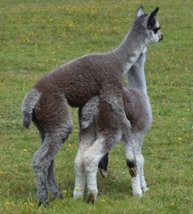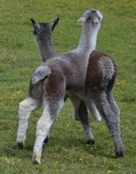

From a few days of age they recognize the other male crias and often prefer to play with them, neck wrestling as well as romping. Males continue to play with other males, will play-mate each other and will try to play-mate with any open females. Then, oddly, they often forget all this and are terribly shy when first presented with a female ready to mate. Their lives are totally bound up with their position in relation to other males in their group. Most of their sexuality is this: fighting, chasing, and worrying about each other. Mating for most in nature would be a rare thing.

Males who get on well together still fight with each other. It is normal. You cannot get two males who do not fight because they are buddies.

Male groups are unstable. When a young member matures or is being used for stud he may challenge other members of the group and there may be a lot of fighting. This usually lasts about a week, and then things return to normal.

Desexed, wethers are quieter and are easily frightened by entire males. We have not found it practical to have wethers and entire males running together. The entire males have bullied the wethers.

If you have entire males a group of at least six is good. They tend to get along better. Keeping an entire male alone may make it difficult to integrate him with a group. Putting him into a settled group in a paddock new to him is safer than putting the group in with him in the paddock he has occupied. When adding a weanling male to a young male group, putting the mildest of those in the established group in with the weanling first and then moving both to the larger group works pretty well.

Occasionally a young male will become dangerous to be around because he will jump on you from behind and knock you down. Don't turn your back on him for a while and be very careful. This has always disappeared for us and was not related to any later behavior.

The males who go on to become sires change with their experience, becoming more confident. This can make their behaviour with people somewhat calmer or less so. It is rare, though, for a stud male to become significantly harder to handle for people as time passes, though he may become more and more dominant in his group of males. However mild a mature working male might be, though, for your safety you should treat him with respect and take care since he can be dangerous to you by accident when interested in fighting and mating. Occasionally a particular hatred might occur between him and another male, so proceed cautiously. Very occasionally an older stud male can become dangerous with people and may have to be put down. This is not temperament though. His relatives are likely to be normal.

All this has to do with the alpacas' lives and very little of it has to do with you. The male who kicks you doesn't dislike you—he just kicks. The female who charges you as though to kill you when you pick up her baby is not paying any attention to you personally, only to a threat to her cria. A protective female who attacks you if you try to do something to a herd mate is functioning well, not badly. It is you who must work out a way around this.

Certainly we all enjoy the sweetest females and the best-behaved males, but some of the animals with the highest vitality and intelligence are not the easiest, while some of the mildest animals are less competent than average. Best not to fuss too much but be moderate in requirements for temperament, knowing your animal might be quite different a few years from now at home.

THE LAND, THE PASTURE, THE ANIMALS

The good shepherd keeps always in mind the condition of the pasture, of the animals (both as individuals and as a mob), the weather, extra feed provided, and parasites.

All these things are related and changing. No firm solutions can be given. Adapting to conditions is partly intuitive.

When you buy land, look around the area. Are people farming cattle or wool sheep or meat sheep? Here, the land we are on is on one side of a ridge. Our side has some good basalt soils with some areas of sandstone. The other side of the ridge is poorer country, mostly the sandstone. The trees that grow on our side include peppermints, with dark bark and thick foliage. On the other side of the ridge there is more scrub. This is an area for breeding cattle, but not for fattening cattle. The land on the other side of the ridge carries fewer cattle per acre.

Rainfall average is around 1000mms. One kilometre away the rainfall can be surprisingly different, and, by the time you get to Braidwood, 22kms away, it is as different as Goulburn or Canberra. The highest rainfall figures can be misleading, though, since a single storm with over 300mms in the middle of winter is not necessarily meaningful by the time you get to December.

In our microclimate it is often very damp (95% humidity) at night and dry by midday. It can be quite hot and dry on a summer day and very cold in winter. The contrasts have lead to our having more experience with pneumonia than average.

Pasture quality differs over the land, but it is mostly semi-improved with about 15 acres that we planted and fertilized. In dry times there is still good ground cover, and the heavy soils store moisture for some time. Our area, on Charley's Forest Road, is known to have a very low weed problem, because of the continuous ground cover and the rainfall and cold. It is not particularly efficient to have a lot of kangaroo grass, which the alpacas don't like, but it is a blessing in drought. One year we managed mostly with dew caught by the grasses. Different years bring different grasses. When we are lucky enough to have good summer rain we have a good bit of weeping grass. There is some wallaby grass and other natives. We don't have grass seeds in ears because we don't have barley grass, but we can have grass seeds in eyes because we have spear grass.

We found that it was better here to leave topknots unshorn at shearing (and trim the long ones with scissors) because we had fewer eye problems—the eyebrows, often removed at shearing, alert the animals to things close to their eyes. However, on a different property the owner might opt to clean shear the heads because of burrs, while on others the owners feel trimming the topknots protects against grass seeds. On a large farm also there are too many animals to handle individually.

The only serious weed in our area is bracken fern. We killed that here long ago.

CONDITION
Mature entire males without parasites on good soils here, with 15 acres of semi-improved pasture and shelter, have had condition scores of 3 to 3.7 in summer, falling to 2.8 or so to 3.5 by the end of winter and into the spring. They have these scores on their own, with supplementary hay in storms or very wet weather. Although those who are 3.7 or so might seem overweight, if you feel other areas of the animals' bodies there is no flabby fat. They are very heavily muscled from having a lot of exercise. If one of these had a condition score under 2.5 I would worry that there was something wrong. Wethers get fatter in the same paddock and are genuinely fat. Note that some animals may have a bonier backline than others but be fat enough if you feel their chests and shoulders. Others may seem fat but have round barrels and be thin. Weighing them is often surprising.

The work done on alpaca nutrition that is reported in the RIRDOC booklet was done on wethers in a controlled environment, not weanlings or females or entire males, and not on animals in large paddocks. If you follow guidelines for wethers you may underfeed your growing and breeding animals.

Having observed the condition of the males in a fairly natural state on the property we accept similar condition scores for the females. There tend to be some fat females and some thin females. Some females can become fat, with no supplementary feeding, on decent pasture, if they are not being bred and having crias yearly. Occasionally you will have a female who doesn't provide sufficient milk for her crias and also gets fat. But, if your female gets pregnant readily and feeds her crias well you may find it best to ignore the fat condition. The easiest way to help control her weight is to breed her at 2-3 weeks after birthing and leave her cria with her as long as possible. This works better than weaning her cria and putting her on a diet.

It is unwise to try to diet a fat female who is early pregnant or nursing a cria since you are likely to lose the pregnancy or compromise the growth of the cria.

Often you can see easily that your fat female is fat because she spends more time eating. Some females have fat/thin cycles. They fatten amazingly and then lose weight precipitously when they begin to lactate. These really need to go into birthing with ample weight on.

Very thin females who do not fatten up on good pasture when not lactating may have something wrong with them from the past, but beyond feeding them extra, weaning their crias promptly, and making sure they don't have parasites there is little you can do. You can try giving them time off, but it often doesn't help. Most can live long, productive lives, as can fat ones. If your female is thin you can still mate her and expect success if you will have her on a good level of nutrition. If nutrition is falling then she is less likely to carry.

With your maidens, if they are growing out to 50 kilos at one year in good conditions, then it may be best to mate them at one year. There are two potential problems with waiting. A female eager to mate at one year may lose interest and refuse at eighteen months. This can take work to fix. Also, if you wait and you have good pasture your young female may get too fat and this may interfere with her getting pregnant. They are capable of growing and being pregnant at the same time.

Males and females naturally eat differently. Males eat relatively little and do not seek out the best pasture. Females are more fussy about quality and eat more.

Through the year there are some general patterns, though drought confuses any idea of seasons. When not in drought, in our environment the alpacas are in the best condition in spring and early summer, on grass that hasn't gone to seed. They tend to be in trim condition then although the pasture will have high protein and energy. Because it is green their dry matter intake is not that high. When it has been dry for some time the animals will get fatter, but may be low in vitamins. The shape of your year will likely be different.

SIZE
Size can vary a great deal. We have adult females of 60 kilos and others of over 90. Everyone has a lot of variety in the size of their animals, whether they have set a goal of having compact animals or large animals. There are genetic differences, and these are not always apparent. So you can mate two small animals and still get a big one.

There are also general differences in size depending on the area in which the animal was raised and sometimes the farm on which the animal was raised.

This is a matter that actually needs serious attention.

In different areas of the country "well-grown" is going to mean different things. There clearly are factors that limit growth in some areas. This goes beyond hand-feeding in drought and seems likely to have to do with minerals in the soil.

Administering vitamin D and phosphorus in periodic injections does not solve it, although these medicines are necessary in winter in southern areas.

Obviously, if your animals are losing condition or actually thin you are alerted to a problem. However, even if the condition (fatness) of your animals is good it can happen that they fall below a good level in growth rate and size. In some cases this difference is genetic, so you may find you are weighing the crias of one male more than another but that these backward crias catch up later. If the problem is not limited to certain lineages, then it is a husbandry matter.

The only solution at present is to give critical substances that we know about (D, phosphorus, selenium) as supplements of some sort. Many alpaca farms, broken into small paddocks, cannot fertilize their paddocks. Many are not on suitable agricultural land. Substitute feeding may work for a small enterprise, but is expensive, and it is impossible for a large operation. I am sure that we, personally, hand feed more than we need to at times, but we do it in order to ensure adequate nutrition, beyond keeping the animals in good condition. When animals are limited to the pasture on particular land there are going to be some things missing, particularly in parts of the year.

If minerals are a problem, free-choice supplement is an attractive option but is proven not to work. Animals who need it may or may not choose to eat it and may eat more or less, not related to their need.

Likewise, alpacas are not very good about licks. They use them erratically, nibbling at them rather than licking. They should have a block available, but it really will not provide something like selenium in any useful quantity.

Various organic options are available and much used, but, while attractively safe, these have very low amounts of minerals in them. An alpaca could have a litre or a kilo of some of these and only barely meet selenium needs for a day in seriously deficient country.

So, it remains a puzzle and one that would benefit from study.

FEEDING
We do feed the females. This we usually do daily, not because they need the extra food every day, but because we need to see them in a controlled environment each day to make sure they are all well. We feed them out of individual feeders. Although they will share hay, mostly, they don't like to share muesli. We may feed only a small amount, but there is something to bring them in. We put out at least 10% more feeders than the number of adult and weanling age animals. This allows the less aggressive animals more options. There are several different areas and the oldest part of the shed tends to be occupied by the most senior females and their crias, with the shy or lower-ranking animals naturally in another space. Some rush to their "own" spot. Feeding in individual feeders works well. Some animals like to sit down when eating and they can do this. Some eat slowly, and this is easier for them when they are not competing with others. In harder times we shift growing crias and animals who need extra into a pen within the shed. They learn quickly to go in there. It is not for long and not a lot, but it makes a distinct difference. This is all work and not suitable if you have 1000 animals, but it is pleasant enough if you have smaller or medium numbers. With larger numbers you need to organise hay in hard times and observe the animals by weighing or condition scoring them regularly. Whether they need hay daily or twice weekly or what is up to your conditions. For example, we could not put large bales of hay out in the paddocks on the ground for ad lib feeding. Humidity at night here is often over 90% and there is sometimes so much rain that there is standing water on hills. On the other hand, in drier areas you can put out large bales and just put a tarp over the bales when it rains.

If you have NO or little pasture then you will need some good quality feed with proper energy and protein. You can find information about this relatively easily. Richard Dixon's articles are useful. An old rule was to balance a ration using at least four substances. This was to even out the pluses and minuses in nutrients due to the land the feed was grown on. It is still a good idea if you have no grazing to feed a variety. If you are buying a lot of hay the supplier may have tested it. Ask for the test or test it yourself in case you need to balance that hay with something else. Testing fodder is not expensive.

More difficult is how to balance having some pasture with what you feed. We do not have many options here. Where I lived in the US animals had no grazing from at least November to at least April. You had to buy your hay in summer and store it. However, hay was comparatively cheap, varied, and of good quality. You could buy purpose grown grass hay--in our northern area, this was commonly pure timothy--or legumes or various mixes. You fussed about things like second cutting, early flower, and so on. Trefoil, clover, and lucerne were the available legumes. The lucerne was soft, with fine stalks. You needed different sorts of hay, with some lucerne for cold weather.

Here we have lucerne, some clover (though it is hard to get), oaten, and meadow hay, occasionally lucerne/rye. (There are other options further north.) The meadow hay available in our area is often late cut and not good. It is not purpose grown. The oaten has often gone to seed and is almost white in colour, more like bedding straw. Some is a failed crop, not purpose grown hay. So much is wasted of the lower quality hay that it not worthwhile to buy. When you buy hay you want the vitamins and minerals it should have, not just fibre. Which brings us back to lucerne and the various chaffs unless you have a good supplier of other hay.

If you have pasture and are feeding extra in winter and bad weather to keep the animals in good condition, lucerne either as chaff or as hay works well and is economical. Soaked, cracked lupins work well mixed with lucerne chaff. When quantity of pasture is a problem, then adding something else--cereal chaff and bran--becomes necessary, but continue to keep track of the likely amounts of energy and protein in your feed. A small amount of LT soy meal is good. You can feed high protein supplements when the animals are eating low protein winter pasture, for example, but if they have no pasture a diet totally of lucerne will leave them hungry since you will not be feeding that much. Nutritional requirements are based on dry matter values and consumption is figured at a certain amount per head (though some individuals may eat a lot more or less).

Remember that very wet pasture that comes in response to rain pleases the animals but doesn't have a lot in it, and they fill up with it, so some lucerne hay or chaff and lupins is a good idea then, to get them over the change. They will need the minerals. The requirements for magnesium, in particular, are fairly high for lactating females, and this is a daily requirement.

Be aware of enterotoxaemia. Unfortunately the 5-in-1 component for this only lasts three months. So, always do things gradually and, if you can, adjust what the animals get naturally. Hay or chaff for about 5 days when there is a major weather change is a good idea. If you have highly productive improved pasture you may need to feed them in the morning and limit their time on the best pasture so that it is a smaller component of their diet.

One way to think of feeding alpacas is to feed for good tensile strength in their fleece. Read about fleece breaks and tender fleece in sheep. Remember the difference between your different categories of animals—you need a higher level of nutrition for breeding females and growing animals than wethers, so consistently low nutrition to match your least good conditions is not appropriate for your breeding animals.

Any hard objects, like lupins (even soaked) or grains or pellets are best fed mixed with chaff at no less than four (chaff) to one (hard stuff) proportion. Dampening the mix a little is a good idea.

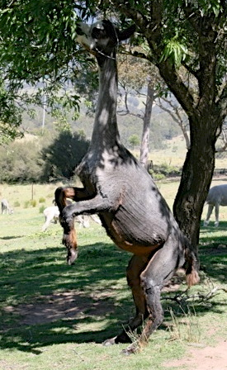
Alpacas like browse. They don't mind bitter thngs. They will eat blackberries, roses, sedge grasses, leaves and twigs of seemingly inedible plants like native blackthorn.
They like some weeds/forbs. For example, they like sheep's burr when in flower and the leaves of shepherd's purse. Sometimes they will add flower heads and seed heads to their diet. Some things they eat only in a certain state. However, they also may devour a plant on a whim. A tree can sit there for some time and then one day you will find your alpacas eating the entire thing. Some wattles are obviously tasty. If you have a convalescent animal with little appetite some safe browse like thornless rose stems with leaves may perk her up.

Always consider where you are. If you are on the coast your problems are unlike those of people inland.

In time there are likely to be different strains of alpaca suited to different environments.
Lastly, scales are handy. They are expensive, but very good to have, even for a small operation, and can be essential for a large one when you are not able to pay attention to individual animals daily.

FEEDING CRIAS
Feeding your youngest animals is complicated. They have milk and they eat grass. If the grass is very wet they may not be thirsty. This can muddle up the dam's lactation or make the crias reluctant to take a supplement from you. Crias also can't really digest mature or over mature grass. Cereal hay will amuse them, but often the quality is such that the only bit really useful to them is the grain. They do not need a lot of roughage, though they need some to develop their digestion. Encouraging them to eat your food when there is no appropriate pasture is something you need to improvise. I haven't found any sort of creep feeder that a cria felt safe to enter and an adult couldn't. On the other hand, feeding the dams hay and muesli while they are close-by after birth can make the crias easy to feed later. Some will eat with their dams. Some dams allow the crias to eat out of the same feeder with them. However, a percentage of crias have no interest in eating the food you provide. They SHOULD be eating hay or muesli BEFORE they are weaned unless your pasture is excellent. Remember that crias are conservative. They may only be willing to eat what they are accustomed to.

It isn't a good idea to try to condition score crias as you would adults by feeling their spines. Also feel their shoulders and thighs. Crias should be plump, not trim. They need to grow. Going into weaning they need to have extra weight so that they can maintain their growth and also meet their needs while in transition.

When weaning crias earlier than six months it would be good to do some reading (available on the internet) about procedures with lambs. It is not a simple matter of separating them from their dams. Attention to nutrition and parasites is important.

PARASITES

Although ideal, it is unlikely that you will have double the amount of land you need so as to provide well-rested paddocks. In some areas the summers are so hot and dry that paddocks are sterilized yearly and risk is lowered. In our area, where it is too cold for ticks and can be quite hot and dry for spells of summer, it is possible with a moderate stocking rate to keep worm levels very low and eliminate barber's pole worm altogether. But in some areas people may need to use almost full time drench in order to cope with barber's pole worms and ticks. Cleaning up droppings will not help enough.

A count of 200 is significant for an alpaca. For some worms you don't want any. Alpacas do not become immune to barber's pole worm. Materials on the wormboss site are for sheep who can tolerate a high level of worms. Advisors may not know that the alpacas do not develop immunity to barber's pole. You need a nil count. The main reason a young animal will have a high count and his mate none is that he was unlucky enough to eat a badly contaminated bit of grass. However, some individuals seem to be resistant and present hope for the future.

Up to several months crias may have some immunity (except to barber's pole worms) via their dams, the mature animals used to your property should be immune (except to barber's pole worms), but the young animals are the ones most important to test, individually.

You do not need your property to be without worms (except barber's pole), just to have a low level. Drenching weanlings before movement to a clean paddock can be beneficial and allows them to meet the worms next with a primed immune system. Your young mothers may have worms. There is a drop in immunity from sometime before to sometime after birth, so you might include them in your tests.

Although it is attractive to run various livestock together, it is safer to run breeding females and crias alone. Cattle are a better idea than sheep or goats.

Pour-ons may burn the alpaca, particularly newly shorn and in summer. If you are going to use a pour-on use one for cattle rather than sheep because the sheep pour-ons are designed to penetrate the grease on the sheep and will be too harsh on the alpaca.

The NSW DPI lab is cheap, efficient, and reliable for testing. You can ask for kits to be sent to you (free) and have the samples grown out if necessary, paying by invoice afterward. If you want something special you can ask for it.

See: https://wormmailinthecloud.wordpress.com/2015/09/04/alpaca-worms-carmichael-wormfax-barbervax-etc/

QUARANTINE

Quarantine is difficult, and you need to balance the welfare of the new animals with safety for the rest of your herd. In some cases you do not need to quarantine new animals, particularly if you know the area and the husbandry of the owners. If you don't know, then assume the worst and quarantine the animals.

It is good to test any introduced animal for worms before drenching and then test again to make sure the drench has worked. Even if you are not obliged to quarantine an introduction (as for Qalpaca), it is a good idea to have the animal in an area you won't need for the rest of your herd. Testing before drench is important to allow you to know what eggs will have contaminated the area. Then you can return that paddock to use more quickly if there is nothing significant. As for the dose rate and combinations of drench, do consider current recommendations. Oral drenches are more effective than injectables in other stock, but if an oral drench will end up all over you and the area and not in the alpaca then there is a reason to use an injectable on that paca.

Using one paddock for quarantine and visitors, with frequent use, is not safe. Weeds may grow there, and the grass may have worm larvae from a previous use. If you are using several different paddocks for quarantine or alternating paddocks to ensure that the pasture in them is clean, then you also need to know how long it has been since the last use, what the weather has been like, and so on.

RECORDS

Record keeping is an essential chore. You are likely to find that as you move from a small number of animals to larger your methods fail. You discover you've missed an animal's 5-in-1 or are waiting for a birth that isn't due yet. You need to have some way to look at records both by animal and by herd. If you have your records only by animal you may fail to notice that you have skipped an animal in a procedure, whereas on a simple list of all the animals the exception will stand out. Work out something very clear to you for the most essential husbandry matters. Does your handwriting work for you or do you need type? Do you do better with computer records or paper or both? You will probably need several sets of records.

Having a way to look up something like a dose of a drug you gave earlier is also very handy. With larger numbers and a longer time period your memory will not be enough.

You need to record movements on your farm and be observant of the weather conditions. You need to know about worms and the lives of those that are endemic in your area. The worm boss site and the online Merck veterinary manual are both helpful for this. Usually, a few days over 40 degrees will kill a lot of larvae, while in temperatures under 15 degrees the eggs will not hatch. You need to know when that happened and how it fits with your animal movements.

It is often only later that you find you need to know something such as the date an animal was weaned, or when you had animals in a paddock.

Once you have more animals than about a hundred, methods have to change again and observations need to be organized. Then use of scales on a crush and monthly weighing of the mob tend to become useful, since you will not see things as easily.

These days if we still had many animals we would use a smart phone with dictation to save the time spent recording the animals one by one when doing injections, then write it down afterward.

STRESS

Stress is part of normal life, and a healthy animal will tolerate this. Some of the stress we may impose on the animals can be more serious.

You can estimate stress for your animals to some extent by comparing with yourself. A day shearing is stressful for both you and the animals. You'll both recover in about three days. Two days in an airplane and airports followed by capture by terrorists, isolation, strange surroundings, strange people, and limited food will take a lot longer to recover from. Likewise, your alpaca may lose weight on a journey, be upset on arrival in a new place, and only recover gradually. If the animal goes to a show and comes home he will be happy right away on return to his group, but a total change is harder. If you look at figures for weight in a young animal who has moved properties, it can take time for him to return to a normal growth rate.

So, mostly, short stresses are not a problem, but long-term stress is. Even relatively mild long term or intermittent stress is hard on a young animal since he is also growing. It is easy for us to see obviously stressful situations such as a move to a different property, shearing, bad weather, shedding, showing, and so on, but some are harder.

Having less than they need creates some stress, particularly if they are moving from a better to a less good situation. Moving from a less good situation to a better one is only briefly stressful.

Be wary of confinement. Quarantine paddocks, birthing paddocks, weaning paddocks, and show team paddocks are all stress and parasite hazards, by their very nature. Although your alpaca may not look stressed, there is always some stress with confinement, separation, crowding, and lack of free movement and natural exercise. Stress and parasite risk are both mitigated by good food. But confinement is still stressful. Make sure your animals are in good condition and, if young, that they are growing well, checked for parasites, and not kept in too long. If you have an animal confined for months to stay clean and quiet for shows and your animal is small for her age, thin, stalled in growth, not eating well, or has any parasite load, it is not worth showing the animal and thereby, if nothing worse, losing her potential as a breeding animal. Take an animal who tolerates shows without this treatment.

A special quarantine paddock for new and visiting animals may create more risk than it avoids.

Management groups are stressful to alpacas. My neighbour has different mobs of cattle that he moves around in units. If he puts three mobs into a large paddock they remain in three groups. The calves play together and he can then move those heifer calves as a mob. With the alpacas this is not the case. They want to be together. And they relate in female lineages rather than age groups. Although some separations are absolutely necessary, others might be reconsidered. Again, this is different with large and small numbers. With large numbers you are more likely to need management groups, and, at the same time, they are less stressful to the animals because each group is substantial. But with small numbers, the animals will be happier with fewer groups.

It is very common even on very small properties to carve the paddocks up into small units, for management. But alpacas really don't require these—in a small herd (under 60 or so in the group) you can get the whole mob in easily by rattling some pellets in a bucket, or feed them and do chores like mating at the same time.

Early on we had difficulties managing the animals. When we bought a stud male we penned him in a small area with a wether and then let both out, at which point that wether and two others chased him and he ran all the way to the front of the property (close to a kilometre from the house). Periodically he would show up closer and the wethers would dash out at him and he would run again. It took months to wait until the wethers actually went up there and buddied up with him. Another time we brought home a female and cria, put them with our herd, and watched as they disappeared, running to the edge of a 30-acre paddock. It took us two hours to catch the cria. The weather turned bad, they were newly shorn, and we needed to get them to shelter. We learned that she had never been in a shed before or in a large paddock. Moving animals from paddock to paddock on the property was always a mysterious and difficult process. This all resolved as we learned. It is easy now.

Unfortunately, handling by people is stressful to an alpaca. The alpacas are herd animals, herbivores, and prey animals. We are none of these. We can kill and eat an alpaca. Somewhere in our relationship with the animals this fact exists. They accept our good behaviour and learn trust and reliance, but we are probably not as welcome in their group as a sheep.

So don't behave like a predator. Walk up to them directly, not circling around them; if there are two of you, walk close together; move slowly and hold anything you carry parallel to your body. The possibility of danger clings to you. Movement is not instantly comprehensible (in their world animals move), so the movement of a rake might upset them, even if you do it daily.

Having the alpacas with us at feeding time accustoms them to our presence, but actual handling is still unpleasant for most. They are naturally worried about their lack of freedom. They may be afraid of falling when we want to pick up their feet. Injections seem to hurt them more than other animals. So get things that require handling done expeditiously.

On the whole it is a good idea to leave the animals as natural a life as possible, with other alpacas, with minimum movement.

OLDER PERSONS

You may think that as you get older you will not be able to manage your alpacas. However, you are thinking of doing things the same way you did at age forty, with strength. Women in their late seventies, weighing less than their smaller alpacas, still care for their alpacas.

You tend to work around lack of strength. Some people have a good crush and accustom their animals to passing through it. In any case, you have to use more thought and less muscle. So, say you need to examine a strong stud male with your vet. The simple thing for us is to put him in the van and take him to the clinic. By the time he gets there he is sitting down and the vet can do quite a bit. If a quieter animal is essential, then he can be sedated. When treating the animal at home, even something like daily medication can be managed. Most alpacas will eat muesli with an oral medication crushed in it, provided you add some tasty pellets. One stud male was obliging enough to eat only from his own feeder with medicine in it for six weeks although in a mob in a paddock. Others, you need to separate. If that doesn't work, then a drench is possible. Alpacas react to drench in different ways. Many are surprisingly easy to handle if you put a syringe point (use a small feeding syringe) into the corner of their mouths. If difficult, the obvious solution is force, but if you don't have force then the answer is patience. After all, you may need to do this alone, without any strength.

Once you are older you may not be able to lift the forequarters of the alpaca into a vehicle. Having one person at another door with the lead, lift one knee onto the floor, then the other knee. Often the alpaca jumps in while you are doing this. If you are alone and the alpaca is not too stroppy, put a long lead from the alpaca, through the cargo barrier, and back to you, hold it to control the head and follow the same procedure with the alpaca's knees. This takes very little strength. It isn't always going to work, but sometimes it will.

But occasionally you will fail and need help. Getting older is like that.

Blessedly, making a mistake with an alpaca is not like making a mistake with a horse. As a child I put a bridle on a head-shy horse awkwardly, and he became upset. His owner had to stand on a stool and talk him into accepting the bridle again. It took a long time. She was 90 and only 5 foot tall.

Alpacas don't hold a grudge (well, perhaps for a few days after shearing), and do not form habits as persistently as horses. If you have an upset, it isn't permanent.

BREEDING GREYS

What follows is the result of years of breeding greys and is practical, not scientific. I'm sure that over time we will know more and that what I have written will be out-of-date.

Greys are pretty, with their faces framed in colour, each distinct, and they are relatively rare. The colour is also intriguing: greys seem to appear like magic out of matings of other colours, while, on the other hand, when mated to other greys they produce solid colours as well as greys.

So, there is a surprising amount written about breeding grey alpacas. But although there are no true-breeding greys, that does not mean breeding them is difficult.

I think it is harder to breed blue-black without colour faults or pure whites with no other coloured fibre than it is to breed greys.

The most important thing to note in breeding grey is that greys have a base colour. You are first breeding that base colour. You are not breeding white with coloured fibres but black or brown or fawn with white fibres.

GREY, TUXEDO, MULTI, AND BLUE-EYED WHITE
It is well known that greys pop up from matings using blue-eyed whites, and greys often have blue or grey in their eyes. However mating greys to greys does not produce blue-eyed whites. We have done a great many matings of grey to grey and have never produced a blue-eyed white from them. It probably happens but would be rare. You may produce blue-eyed whites if you breed together greys that have all-blue eyes and also a multi pattern with ventral white.

The white faces, necks and legs on many greys are not usually an indication of a multi pattern or tuxedo. They are largely irrelevant in breeding greys or the solid base colour.

Blue-eyed whites are probably the result of having two white patterns on the same animal. The absence of a pigment that is also associated with nerves can make the animal deaf. Greys are no more likely to be deaf than fawns. The only greys more likely than solid colours to be deaf are those with a multi pattern and also blue eyes. A small percentage of alpacas are deaf to some degree no matter what the colour.

The AAA recently defined tuxedo to include all multis or fancies that are not appaloosas. Here, though, I will use it to refer to the pattern of white somewhere on the face, possibly the front of the neck, and on the lower legs below the knee and hock. It is expressed more or less, and may be restricted in expression to only a small dot of white on the head or a foot.

GREY AND ROAN
The term "white-spotting pattern" refers to any white fibre distribution on a coloured coat. It includes genetically managed white markings of all sorts, including grey, roan, tuxedo, appaloosa, piebald, and extreme white piebald.

Theoretically, any coat of dark fibres with white fibres regularly interspersed is roan. So it would be possible to call all such alpacas roan and then describe them further.

The terms are arbitrary and people have different ideas about grey and roan. Here, to be clearest I will from now on refer to "classic grey" as an animal with a significant percentage of white fibres through the coat and a pattern that shades to white on the face and usually front of neck. I will use the term "modern grey" to refer to animals without the shading to white on face and front of neck (these may still have white markings) plus a high percentage of white fibres through the coat so that they look grey on the outside. I will use the term "roan" to refer to animals that look brown or black or fawn but have a (lower than in a classic grey) percentage of white fibres through their coats (these may also have white markings) obvious only when the coat is opened. It is sometimes hard to draw a line between roan and solid with a colour fault. Many coloured animals have at least a few white fibres or other colour fibres in their coats by the time they are two.

Classic greys are usually darker at birth than they end up, as you can see in these two photos below of the same animal at one month and as an adult.

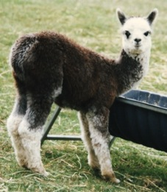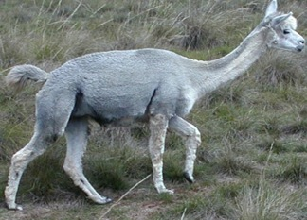

Silver grey crias may look like tuxedo blacks at birth. We have been hard-pressed to locate any white fibres in some and don't know their true colour until after shearing. It is only the fuzzy edges of the colour areas that make it clear they are grey. The photos below show a girl soon after her birth, before first shearing and after a later shearing.
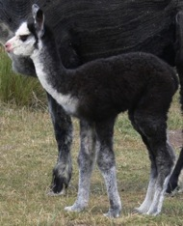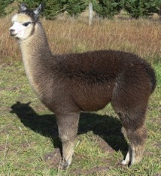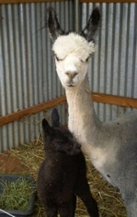

Tips are often faded to red at birth or fade in the first few weeks; so many silver greys are registered as rose grey. Our soils are orange, so the animal on the right is stained. His topknot is white, not orange.

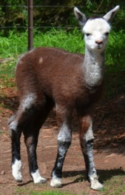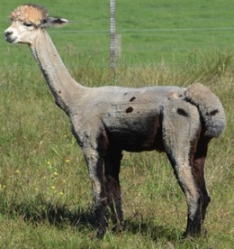

I don't know whether the additional white fibres are secondaries that get long enough to be visible over time or are coloured fibres that turn white. In most grey fleeces most white fibres are finer secondaries. To my knowledge there is no grey fibre but only mixed white and coloured fibres.

Here is a photo of a sample of a first fleece showing the amount of change that can occur. Spots also appear or disappear.

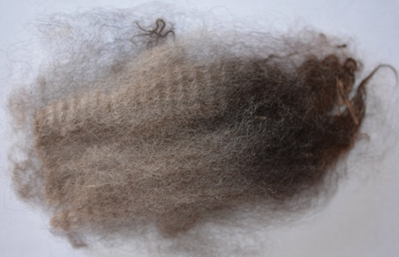

The amount of white on the face and neck can vary from little to a lot but is still the same pattern.

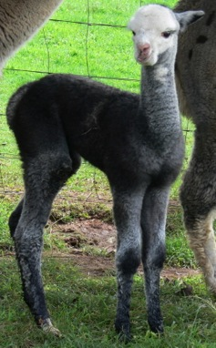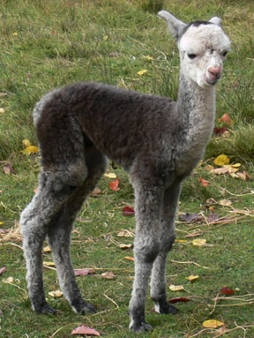

Classic greys change from darker to lighter in their first two years. Then when they are older, primary fibres, which are mostly coloured, are longer and make the animal look darker, but the fleece itself does not get darker. Below is a grey shorn on the left, and on the right in fleece, with dark primaries making her look darker.

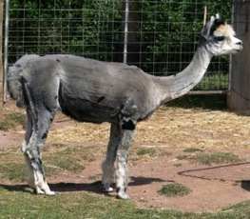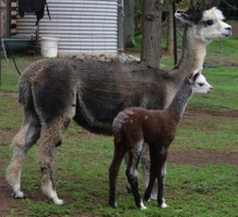

Their colour is shaded a bit over their bodies. For example, you will often notice a change at the last rib from darker to lighter, or a streak of darker colour or a small spot in this area, as you can see in these photos of Platina, first as a cria and then both sides.

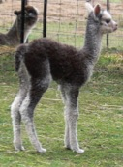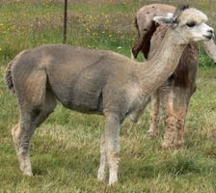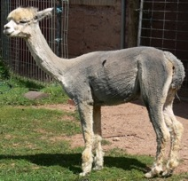
They are often lighter on the edges of their hind legs and hips. Classic greys often have spots. Patterns with darker legs and with lighter legs are both common. Those above, of Platina, show the paler legs, while that below on the left, of her daughter, shows the darker points.

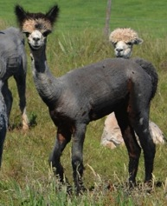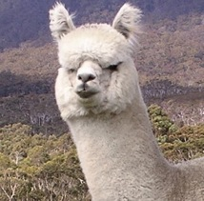

The classic grey pattern usually includes a darker cap on the animal's head (although pale greys, often produced from silver grey/rose grey matings, may be pale or white on their heads (as Elysion Mercury is on right), with just a slightly darker dot in the topknot.

On most classic greys the white areas fill in with colour to some extent as the animal ages. Some that start out with white faces and neck fronts end up grey throughout—a lighter colour than the rest of their bodies, but not white.

Spots are normal on greys, as are patterns. Along with patterns shading to dark or light on the legs, there are patterns with white on the lower legs. This is common and not something to worry about.

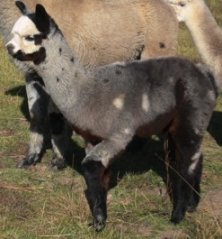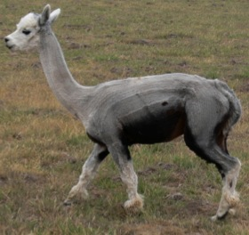

However, this sort of pattern below with ventral white is actually a fancy pattern and grey, so be careful unless you want it!

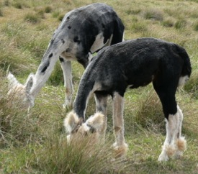

Modern greys (my definition) are rare. The colour may turn darker in colour over the first year. White markings if present are hard-edged. Below is an animal belonging to a friend. This is a rare colour.

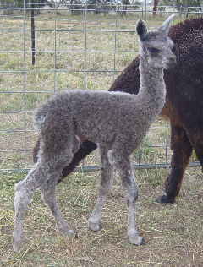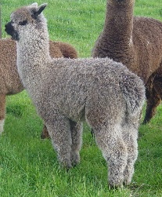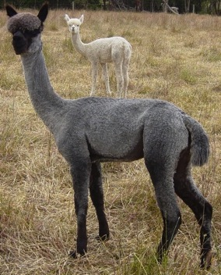

In roans the white fibres are very fine and close to invisible on lighter colours. On dark colour they show up gradually, most obviously first on the neck, which often turns a darker shade, too. If white markings are present they are hard-edged.

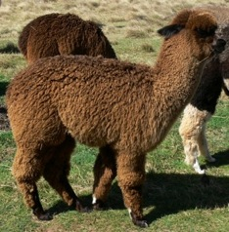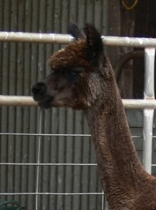
On paler animals it can be hard to distinguish a very pale rose grey from a roan or from a vicuna fawn or a multi. Sometimes it is clear after their first shearing, sometimes it is clear at birth but not later, but other times the colour of such animals remains puzzling, perhaps being more than one colour.

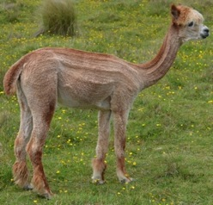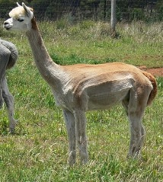

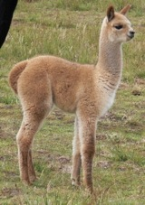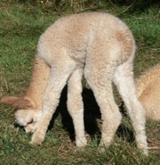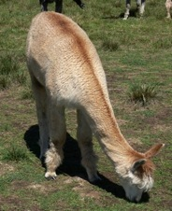

The colour may be deep on the backline and become paler further down the body. Darker roans may have still darker base colour on their necks, heads, and legs, while their necks tend to show roan first. The colour on their heads and necks seems sometimes to darken over time. White markings on the darker roans are hard-edged.

I have little personal experience of either modern greys or roans, so from here on I will be writing only about the classic greys, clearly grey on the outside and shading toward white on the face and usually the front of the neck.

There are a great many colours of alpacas, far more than our list allows, and there are some rare and quite beautiful colours.

GREY PLUS TUXEDO EQUALS CLASSIC GREY?
One explanation of classic grey is that it is a combination of grey/roan plus tuxedo pattern, with the genes so close that they usually travel stuck together. Modern greys and roans then are the result of the tuxedo component being missing in some animals.

My observation doesn't bear this out. The white areas on a classic grey are not sharply defined with permanent borders as with a tuxedo coat.

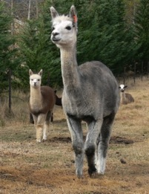
The white areas on a classic grey are also not really white but often have coloured fibres, and the colour may increase with the animal's age.

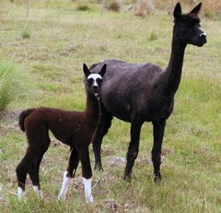
Tuxedo can be anything from white face and front of neck plus white socks to just a dot of white on the nose or thin ringlets on the feet (as in the mother, on the right). Interestingly, mating a tuxedo to a grey may result in more white on the offspring, as in this case. This female produced a wide variety of colours when mated to different grey males.

The patterns of classic grey also are not those you would expect of tuxedo. Classic grey has the half white neck and full face pattern much more often than you would expect from tuxedo and shows limited pattern much less often.

Generally, matings of classic greyto classic grey do not produce tuxedo white markings more often than non-grey to non-grey matings. And matings of classic grey to solid coloured do not produce non-grey tuxedo patterns more often than matings of solid colours to solid colours.

Random spots on the body of a dark coloured non-grey animal, such as a white spot on the shoulder of a black animal, are not tuxedo markings and do not seem to be something to avoid in breeding for grey. Even clones have different markings. Small spots also appear or disappear.

Roans and modern greys may have different patterns, such as the darker neck and head, combined with very smooth colour over their barrels.

If you mate an animal with white markings on face and feet (even this small white spot on her face, not visible until she was mature) to a classic grey there is a significant risk of producing blue-eyed whites or tuxedos with a larger percentage of white than the tuxedo parent. However this may be an individual animal matter. Another female here with much more white on her face produced solid black regularly with grey males.

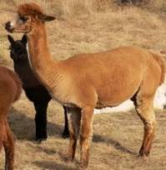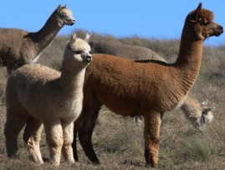

So I think of classic grey as a separate pattern. This, though, does not explain how roans and modern greys appear from time to time from grey/grey matings.

Eventually we will learn what is going on from the geneticists.

BREEDING CLASSIC GREY
It is possible that classic grey is homozygous lethal. This would explain why greys do not breed true. This means that all classic greys have one grey and one non-grey copy of a gene, with the homozygous grey embryos lost, leaving one third base colour offspring and two thirds grey. These losses do not mean that you have stillborn crias or late abortions. Mostly the losses would be early embryos, and the number of these losses would disappear in the normal luck of breeding alpacas. I've heard that in ET, embryos from grey/grey matings have a 10% greater chance of being lost between 10 and 14 days.

In breeding classic grey it is sometimes advised to breed the grey to the desired base colour rather than to a grey in order to avoid making blue-eyed whites or risking abortions.

We haven't had blue-eyed whites born from grey/grey matings. We also don't seem to have misfortune more easily with grey/grey matings than with base colour/grey matings.

If you prefer to breed classic grey to base colour you should get around 50% classic grey and base colour rather than 66% grey with mating grey to grey. Our figures for mating grey to non-grey give about 50% grey progeny, but there are not enough results to be sure

It is possible that blacks and bay browns from grey matings may produce grey at a higher rate than if from non-grey ancestry.

The particular pattern of your classic grey may influence outcomes, but you won't really know this until you do a number of matings. A number of grey stud males from white matings have bold patterns with a lot of white on the legs. This does not seem to be significant. On the other hand, some "signature" markings may show up. One of our males had a bit of fawn on the top of his back and we have had crias with this; another of our males had some almost invisible speckles on one hip. These also showed up on offspring occasionally.

Altogether we have had about 2/3 grey from grey/grey matings. Within this 2/3 I place a small number of very obviously roan (or modern grey) animals and a few pale fawn greys. Of the 1/3 who were not grey about 2% had white markings on heads or below knees. Of the solid colour progeny about a quarter had some roaning or speckles or other colour inconsistencies. Many solid colour animals without grey ancestry also have roaning, speckles, or colour inconsistencies. I have not found that dark solid colour animals with roaning produce grey better than those without roaning, but the sample is too small to judge well.

IMPROVEMENT
It is often suggested to breed to white and pale colours in order to improve the quality of the dark coloured animals. Since whites consistently win at shows over other colours, except for the palest fawn, it is alluring to use them. Breeding white to grey you risk making blue-eyed white. This is not such an awful result—some prominent lineages go back to blue-eyed white females, and a number of well-known grey males are out of blue-eyed white dams. BEWs are not popular, though, and you also do not know what colours they carry until you have offspring. They are by no means reliably "crypto greys". If you mate them to solid dark colours you will find out what they can do. We had one who made greys well.

In breeding to whites and light fawns you run into animals who offer no genetic possibility of making dark colour and into animals who carry some dilute factor. Many greys and dark coloured animals with part Peruvian pedigrees carry dilute factor. When you add several doses together you end up with a pale animal.

Breeding greys to whites or light fawns also risks making base-colour coats with white markings. The whites and light fawns may have markings you cannot see.

It is also an option to seek out pale animals with roaning, striped or dark toenails, dark skin, or other characteristics that suggest they are invisibly grey or carry dark colour. However, there are problems with doing this. It is hard to get back to your dark base colour, particularly to blue-black. Mostly you will get more pale animals. Also, quality changes with colour.

Unless you are very lucky you do not get something halfway in between your grey (or black) and your white (or light fawn) in quality. The result will be different. It will be hard to judge what the difference will be in advance. If it were easier or more reliable to do this there would be more dark coloured and grey animals winning championships at shows by now. Instead, two decades have not produced many browns and blacks and greys that compete at the same level as whites. There is now not as great a difference as there used to be between the best coloured animals and the whites and light fawns, but it is still there.

Note that grey and black fleeces on full siblings will be different. Over time you will likely find it easier to figure what the difference means.

If you are going to experiment it is more advantageous to use high quality light coloured females with grey males than to use high quality light coloured males over grey females because it is wise to conserve the rarer colour. Your silver greys are also black base colour, so recessive, which means it could take several generations to get back to your black base colour. Doing this with grey and wanting both the dark base colour and the grey makes it doubly hard. You are inevitably going to produce fawn, because that may be the darkest colour in light coloured females, and you will also have to struggle against patterns and almost invisible colours. Light colours are epistatic to dark. So you will see the lightest colour expressed. Certainly you can do this, but it will take time and large numbers. You need to be able to keep your fawns and wait for them in turn to have offspring, and so on.

Over time if you mate grey females to light colour males you will have an increasing percentage of fawn and pale roan in your herd, especially if you pick the "best" to go on with regardless of colour.

If you have a small operation it might be wise to buy the successful results of someone else's experiments!

If you want blue-black, red-brown with black points, browns without shading to paler tints, cold silver grey, and genuinely pink rose grey, then you need to keep in your herd the animals who can make these colours, even if they are not otherwise your best animals.

Improvement does continue even if using only greys and dark colours.

At any rate, we have mated greys to greys and non-greys. We ignored spots and markings and still ended up with a good percentage of smooth coloured greys and solid non-greys. A white foot on a classic grey doesn't mean you will get any white markings on base colour progeny. Matings of grey to other colours seem more likely to produce patterns and spots in your greys, while mating greys to greys over several generations tends to produce somewhat smoother colour, but there is not a lot in it. I don't know whether you can breed for spotless colour successfully. Limiting the breeding herd in that way leaves fewer animals of good quality to use.

We paid attention to base colour and to grey. I had thought that possibly pale greys, often from rose grey/silver grey matings, bred to each other might reliably make more pale grey, but they don't. Dark, medium, and light silver really aren't much different in breeding, though to get dark grey it helps to start with at least one dark grey parent. It is mostly the base colour plus the grey that counts. A pale colour isn't better in fleece because more like a white (instead the dark primaries stand out). However, rose greys are likely to have better fleeces than silver greys. The black fibres tend (overall) to be stronger micron, and silver grey fleeces are likely to be a little less fine and even than rose grey fleeces. However, on any particular animal the darker shaded areas may be softer. Spots on your greys may be quite different, in fineness and even in length.

The base colour can be blue-black, fading black, brown, or fawn. The easiest base colours to work with are black and deep red-brown with black points. The hardest base colour to work with is fawn.

If you have whites and light fawns and want to move to dark colours and greys, I'd advise using a solid black or brown male with grey in his background, then, if you want grey, mate the solid colour progeny to grey. White fibres in the male's coat are probably not significant, but you don't need to avoid a male with them.

Such are my thoughts, if they are of any use to you.

BIRTHS

There is quite a lot to say about births, so I will write about things we might do differently here or simple things that I learned only after some years.

Things to look for pre-birth are: not eating the previous evening or the morning; humming, especially when the female is answering another animal she can't see; a dirty coat from rolling; a soft, sweet expression from a female who is normally not soft or sweet; keeping a distance from the herd; close presence of an older alpaca observer who has been with other births recently; general interest and sniffing from other females.

However well you know your female she may be different when birthing. Some try to get away from the herd, which doesn't work terribly well since the others often follow. But the company of the other animals is normal. At this particular time, a human isn't normal. So be discreet. At times I have hidden behind bushes with binoculars.

If the female is near or over one year's gestation and she is uncomfortable, particularly in the late afternoon, consider a vet visit. These crias can be badly stuck or rolled up and do not necessarily stimulate contractions until too late. Unless it is prolonged, the same behaviour before her due date is probably not significant but due to the cria turning.

Females will sometimes come to you for help. They may really need it then.

If you assist a birth continue until the cria is fully out. By assisting you have disturbed the process and it may not continue in a normal manner if you go away part way through the birth after fixing the apparent problem.

We do not use a birthing paddock. We tried it several times and it didn't work for us. Our birthing group tends to be too small to make up a herd and the main herd usually is out of sight of the confined group for much of the day. There is more stress and less exercise for the late pregnant girls, which isn't a good mix, particularly if they have extra feed available. The same extra feed if the animals are out with the herd on 30 acres is not an issue.

We leave the late pregnant females with the herd and I go out every two hours to check them.

If you are getting over-large crias or having a lot of problems you might consider whether you could dispense with the almost universal practice of putting heavily pregnant females in a small paddock. If you are working full time and getting home after dark you may really need to keep the animals in a small paddock you can explore with a flashlight, but otherwise, if you are able to go out to them you do catch problems pretty easily. Many females will let you assist if they are in trouble, without another person to hold them. With some thought you can also, if you need to, move them into a smaller area without stressing them.

Smaller crias, born easily to fit mothers, tend to be up and nursing faster than large crias born to confined mothers. The cria needs a level of fitness because she actively assists birthing, pushing with her hind legs and working to get her front legs and head through. If she gets too tired then once born she may be flat and not up to standing and drinking as quickly as she should.

The birth and first hours after birth involve interaction between the dam and cria. On the whole they manage this themselves, but there are small interventions that can help, particularly with a first birth. If the cria is not sitting in kush after some time, give her a rub and help her move to a sitting position. If she just sits and doesn't seem to be trying or succeeding to stand after an hour, stand her up. Once her muscles understand the position, it is easier for her to repeat.

If you find a flat, cold cria, wake her up and get her warm.

Occasionally you get one who can't thermo-regulate properly. Add active warmth to her environment in some way. A cria also doesn't understand heat and shade. If it is hot get the cria and dam into shade soon. New mothers may want to keep their crias away from you and other animals at first, so try to organize the space where you put them so that it is logical for them to be in shade.

Once you have warmed up the cria if necessary, if it has been two hours and the cria has not had a drink, you can give her something—some glucose or a tablespoon of honey in 80 mls warm water, or Impact. (In mild weather you can wait an hour longer.) This generally moves the interaction forward and the cria looks more eagerly for the real milk. A cria always wants her mother's milk.

Don't hang around petting the baby—do what you need to and get away to a distance. You need the interaction to proceed with each partner acting and reacting, to each other. Your interference is solely to compensate for gaps or flaws in the process.

On the other hand, once you know normal births, and if your female is comfortable with you around, you can gently keep the process moving, helping with a longer birth, standing the cria up, giving a drink, pointing her in the right direction.

Your female will probably like some hay and water.

After a birth if weather is okay we leave the pair for a while to bond (with a bucket of water and some hay) then move them to a paddock close to the shed with shade and shelter, food and water. It is in the first two weeks after a birth that we have had things go wrong, so we keep them in for two weeks. We can observe both, weigh the cria easily, and move them into shelter easily if needed. Often during this period, when there is little competition, crias start to nibble hay and muesli. This is helpful later.

If a maiden mother is not nursing the cria but the cria is eager, make sure there is milk and consider asking the vet for oxytocin and a mild sedative if she is nervous. You can feed the cria some Impact if she is hungry, but don't overdo it. Although some materials will tell you to feed the cria at intervals overnight, we have tried not doing this and it is possibly better not to if you think the mother may start feeding the cria. The cria should be okay during this period as long as she is warm and safe. If the mother has died or is truly unavailable, then feed the cria on her first night.

FLAWS
It happens that some crias are not perfect at birth. They may be flat, they may have lax tendons or over-tight tendons in their legs. They may be so disturbed by the birth process that their nervous systems take time to catch up. Within three days to two weeks most of these problems disappear. Even if you see something that seems very serious, like a heart problem, this may improve, and it may not be an inherited flaw. There are fewer flaws today in alpacas than there were 20 years back or with imports from Peru.

Remember that "congenital" means "present at birth". This includes environmentally caused problems. If a flaw is genetic, and heritable, it is of course wise to be careful. Some flaws, such as hermaphroditism, are known to he highly heritable in other livestock. However, to take one well-known defect, choanal atresia, it is not clear that it is inherited. Logically, there may be a genetic component in some cases, but environmental factors may also be a significant part of the cause. It is not sensible at this point in time to withdraw animals from the breeding pool because of this. If you think you see choanal atresia or another defect that might be heritable, it is wise to consult with a vet and get a firm diagnosis, and it might be a good idea to take a drop of blood on a blotting paper for analysis when a test is available.

Crias are strong. You can achieve a very high birth rate if you spend a little time doing simple things to protect them after birth. Although you cannot ensure that they are free from environmental effects, like extremely high heat, you can to some extent be careful with chemicals. Also, you can avoid close-breeding. The flaws in camelids may be due in part to close-breeding in South America.

FEEDING A CRIA
It sometimes happens that you need to give a cria a bottle. Many are not easy to feed though they clearly need it. I am hopeless at milking the mothers. I have never had to rear a cria from birth, but on occasion I have had to feed the cria for a few days after birth or from one month or so. I have also supplemented crias who are not getting enough milk. I have only two bits of advice. The one is to try (if it isn't going well) a very soft teat used with another cria. The other is to be patient. Most of them need to try the teat and the funny milk and get used to it, so if it doesn't work, try later. Don't worry too much. If you are supplementing or totally feeding an older cria it can take over a week of trying twice a day. Then they give a little sigh and decide to compromise their standards. Crias settle into little rituals about their drinking. As quickly as possible try to get the cria to come up to the bottle with minimal handling. It doesn't do harm to hold them but it is easiest for you if they come up. Mother alpacas tend to nurse their crias at the same time each day. Watch for this and catch your cria during nursing or soon before and give her bottle. She will still nurse from her dam and will not turn to you instead, as a lamb or calf might, because it is easier to get milk from the bottle.

Feeding a cria is nowhere near as easy as feeding a lamb. It is great when you can walk out into the paddock and have the cria run up, but often that doesn't happen, so you can't rely on being able to do that. You have to leave the cria with other pacas and you have to plan on having to catch the cria, at least for some time.

Always leave the cria with alpacas. If you have to take the cria with you on occasion and bring a companion, you can do that, but then put them back with other alpacas. The outcome will not be good if you separate the cria as you would a poddy lamb.

WEANING

The relationship of dams and crias is the most touching part of breeding alpacas. Suddenly your female becomes soft and attentive and loving. Just seeing her want to be close to another animal is startling. The crias follow their dams' lead. I have watched a cria closely observe her dam's behaviour, eating the same little bit of grass, relieving herself in precisely the same spot right after her dam, and playing with her.

Based purely on eating and digesting food, a well-grown, well-cared for cria, kept with her herd, can be weaned at three months. However, psychologically, crias are not independent before five months of age or more. It is at about five months that most will start focusing on you and on their environment. It is at about six months that they will begin to behave more independently. It may be necessary or convenient to wean them before six months of age, but when possible they are best left to at least five.

To what extent is weaning necessary? If the dams are pregnant they will, with rare exceptions, stop nursing their crias at least a few months before the next birth. We've had two who would let their crias nurse close to the next birth. Those have to be separated. For many females, the next birth determines time of weaning. So they may nurse for five to seven or eight months with a birth due one year after that cria's birth, or for as long as eighteen months if they haven't been remated.

Unfortunately, a stubborn cria can be "weaned" for several months and still convince her dam to feed her again. Sometimes this means that the female will not hold a pregnancy. So then you need to keep them apart until the female is several months into her next pregnancy.

Male crias have to be weaned at some point, and any cria may have to be weaned if the dam is too thin. Fortunately it often is not necessary to wean your young females. Being together benefits both the dam and your female cria. The dams gain confidence and status when they have daughters in the herd. They are happier. The daughters are more likely to have problem-free first pregnancies and births.

On a property with lots of small, adjacent paddocks it is not too hard on the animals if you separate management groups and have your yearling females separate, but they cope much better together in a herd with adults as long as there is a lot of space. I've tried separating yearling girls, but with just six they were upset. Many of the young females don't like to be observed and will tuck themselves behind adults in a herd. It was hard to get a photo of Platina, who kept gliding behind her mother when I had the camera pointed at her. When in a smaller group and singled out they are nervous. Why upset them?
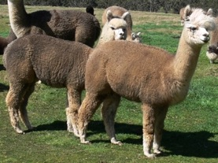

When you do have to wean young animals, or if you have to separate any animals from the main group, be cautious about stress. If you are putting weanlings into an area with no pasture where they have to compete for access to something like oaten hay you are risking their health and proper sexual development. At least give them all the food they want and a way to get it without competition. Give them some variety if you can and remember that they need higher energy, protein, and minerals than you would offer as a maintenance diet to wethers. Don't worry about their fleeces "blowing out" at this time. Give them lucerne and, if you have it, offer clover in addition. Give them enough space that they can graze in some good areas that are free from latrines. There really shouldn't be deaths at weaning.

Although a few crias resist eating anything but grass, most will try hay and muesli if they have enough space to do this without competition. It may look as though they aren't interested when in fact they feel they can't compete, even if it looks easy to you. You need to put out enough feeders or put hay out in enough different spots that there is a spot for each cria as well as each adult, plus a number of extras. Although individual feeders are awkward for space and may seem all wrong for livestock, they do work for alpacas well, especially if you have shy or uncompetitive animals or crias you want to feed. So if your operation is small you can try this. If your operation is larger, then you may already time births to make best use of feed and have areas of particularly good pasture for nursing dams and for your weanlings.

HALTER TRAINING
I have little to add to the great deal that has been written, only that it is better to keep early lessons very short, to walk the animals (when they are ready) in areas that are not their pasture, and to adjust the length of the lead to the behaviour of the alpaca. Some animals with a large personal space need a longer lead, while others become anxious unless you are touching them.

RAISING HAPPY, HEALTHY ALPACAS

Give them space and pasture, shelter and feed in bad weather, monitor parasites, and you should have beautiful, healthy animals.

If you watch the animals on a property where they have lots of space you will notice that they use it. Our females normally have thirty to fifty acres. They walk around about thirty acres of that, most days. They care about where they are. They will trot up to the top of a hill to see a rainbow better, run down a slope to get a drink from a spring midday, potter out to the best pasture when we open the gate, and, on a frosty morning, go to the top of a hill or the edge of a forest to escape the cold. They notice where a fox has passed by, check on a spot with different grass, camp in one area, and graze in another. They find a particularly spiky native grass to roll on today and another tomorrow, hopping up afterwards and leaping in the air. The whole mob, including aged females, goes on a nice run, pronking. This is part of a vivid life for intelligent, active animals. They are not meant to occupy a half-acre and be fed a measured diet. Nor are they meant to romp around in small circles in the morning and evening and otherwise stand around.

The advantages of small paddocks are greater docility and being able to adjust feed more precisely to needs of different groups. The advantages of larger paddocks are greater fitness, strength, health, and beauty.

Equipment causes injuries. It is the corners, the pens, the gates, the dodgy bit of fencing, and the fights in small spaces, that are risky.

A landscape with some diversity is better than flat, planted pasture. If you have flat pasture consider planting different seeds in different areas to encourage the animals to move over the whole thing. Or, put watering points in different areas. Add some areas of trees. I've often thought that enclosed hedges of multiflora roses (grown regularly as rootstock), which they love, would be a nice addition.

It may sound odd, but hand-feeding is in some ways more healthy than providing pasture. Pasture changes and is dependent on seasons and the soil. There isn't much you can do about it when a problem grass, such as rye, is a major (and productive) component of your pasture, or when weather conditions mean your pasture is toxic. The fast-growing, fertilized pastures that suit cattle that are deposited in a big mob for a fortnight and then moved on, are not the safest thing for alpacas. Metabolic problems are more a risk on planted, improved pasture. Established grass-dominant pastures are easiest to deal with for breeding alpacas. Cocksfoot, grazing brome, and good native grasses are all good. Newer white and red and Persian clover are good in modest percentages. The production grasses for intensive grazing are probably not that suitable. You can offer a cover crop of oats with a nil-endophyte rye, but with any new, improved pasture be careful about how long the animals are on this at first and limit grazing, particularly if it has been heavily fertilised. In our area pastures are put in for cattle, so although I ordered Gala grazing brome in one paddock, I found out afterwards that we got Atom prairie grass--much of a muchness to the person sowing it, but not to us. Aim for something permanent because it is safer, less work and expense, and allows fewer weeds. Unfortunately, weeds can come in with the seeds. Also, the disturbance to the soil allows seeds in the soil to sprout. One paddock we planted in 2004 grew so fast (Atom prairie grass, other grasses, red clover) that we simply closed the animals out of it for a season. We last planted in 2006 and still in 2014 have better grass in those small paddocks than we did before, so it is worthwhile, but a risk at first. Make sure to note the production number of the bag of seed. With this you can access test information on that crop.

Fertilizer and lime can change the grasses that you have, allowing some seeds in the soil bank that like better conditions to profit.

If your property has bracken fern on it, read the Merck veterinary manual online entry for bracken fern. Even though people have eaten it, it is seriously bad. Alpacas do eat bracken, even mature fronds, even with quite good pasture, because they like to browse woody plants and do not really mind bitter flavours. Consider getting rid of the bracken right away by spraying it. Pulling it up or repeatedly mowing are possible control measures you will read about, but these "control" methods still mean you have new fronds coming up, and alpacas have died from eating these. Even if you cut it or pull it up daily for months it continues to put up fronds. It is simply too poisonous to have the animals have any access to. Cultivating and planting help, but it comes back. Bracken fern also inhibits tree growth and takes up a high percentage of the water and nutrients where a large stand of it is growing. So if you want to do any revegetation or pasture improvement, get rid of it first.

Similarly, with other weeds and toxic plants, do your reading, know your property, and deal with the weeds in advance if possible. Once you have carved your property up into little paddocks it will no longer be possible to do much work with the pastures. If you are new to your land, check with the district vet, the local vet, your neighbours, the shire, and so on, about known problems in your area.

Be aware that in an area where a problem is long-established people might not think about it too much. But if you are new to the area the problem will require more thought. Declared noxious weeds are weeds that people are intent on killing or keeping out. For example, in our shire there have been very few sightings of fireweed (26), mostly on roadsides, and they are eradicated quickly and the sites observed. It is a declared noxious weed. The Bega Valley on the other hand, after an intense campaign, has recently given up and dropped fireweed from the list of noxious weeds. So, in some areas it may be not declared because there is no chance of its occurrence, while in others the problem might be so bad that "control" is felt to place too large a burden on the landholder

COATS

A coat can save an animal's life. You can buy them but you can also make them. I have made two types, one with a waterproof outside and lining, and one of just a wool blanket. A key is to have a cloth that doesn't squeak or rustle. There are places in the US that sell it. If you type "waterproof breathable" into the search field on your browser you will find the sites and can ask the people to send samples.

This is a cria coat with cordura outside and wool blanket inside. They can also be made with just wool blanket, with a loop around the tail to keep the coat from folding up.

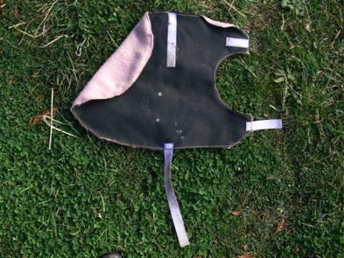

Heavier cordura works for cria coats and lighter, waterproofed cordura works for adults. This is a winter coat with thinsulate insulation and a wool lining.

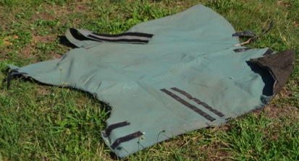

Alpacas are colour sensitive and some mothers are puzzled or upset by the change in the cria when you put on a coat. If you make the coats yourself you can order the colour you want. If you breed white, you can buy white cloth.

A wool blanket coat is very handy when you want to give the animal some protection but don't want to be taking the coat on and off. It will prevent sunburn and actually keeps the animal dry without risk of overheating. The minute you take the coat off, moisture on the top will soak in and make the coat wet, but you will find your animal dry in everything but the heaviest rain.

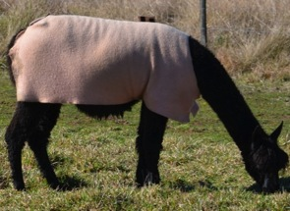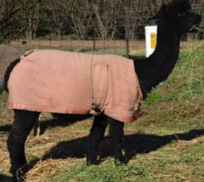

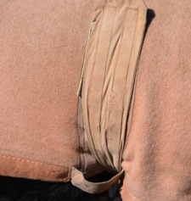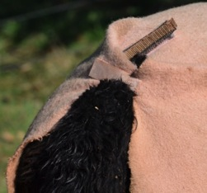

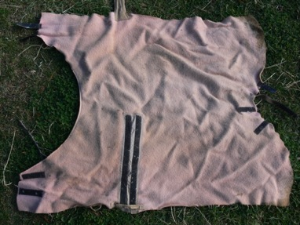

Polar fleece stays warm even when it is wet, but it isn't strong enough as a coat by itself and it is uncomfortably hot when it is warm. Wool behaves like fleece, naturally!

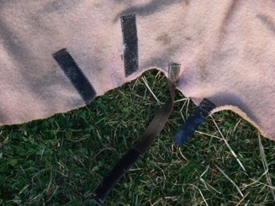
Animals tend to fuss about something around their hind legs so I've used a loop under the tail. They don't mind this. You can see how it works in one of the photos above.

If you try this pattern, don't omit the band that you slip the girth through. If you omit it the coat can come loose.

Details like gathering the neck a little with a running stitch and then sewing on binding make the coat fit a bit better. The tab to attach the coat over the tail helps cover the whole alpaca when she sits down.

Please be careful when you put the coat on to have the animal in a safe area, where you can catch him. Occasionally they get too upset to wear a coat. With crias occasionally a dam does not recognize the cria with a coat and runs away when the cria comes up to her, so, again, try this in an enclosed space first and make sure the coat is not a problem.

MEDICAL MATTERS

Sometimes it seems there is so little we can do to diagnose and fix problems with our animals! In truth, things go wrong that we can do very little about. Mesenteric torsion, for example, is out of our control. Possibly if the animals could tell us, we could act, but they can't. Some illnesses, like pneumonia, we can treat with drugs, while others, such as injuries, we can help with. Our vets can diagnose problems and treat many things, but means are limited in comparison with what we can do for people.

So, what is our role?

It is worth noting that history is vital in making a diagnosis. A blood test, for example, is interpreted by the lab in light of the history. Without history it is not as useful.

So, history is for us to supply with observation. We do all miss things, but regular observation and careful records are very useful when there is a problem.

Nursing care is also far more valuable that is often guessed. This care has to be provided carefully, balancing stress for the animal with benefit for the animal. When there is illness all of us get upset and find it hard to think things through, so a friend is often helpful to point out the obvious. My vet has been very helpful to me in this way. Also, when both Royall and I are here we help each other and notice different things.

Temperature is perhaps the first thing to consider. A sick animal may not thermo-regulate properly. And an animal with a fever needs help to reduce the fever.

Reduced movement is also necessary. An animal with pneumonia who is trying to keep up with her herd will continue to try to do that until she can't. She needs the least possible stress on her lungs. A male with a leg injury might not recover if injured again, so needs to be separated from his mates until he is thoroughly recovered.

Over-the-counter aids like ADE, VAM, CophosB, and so on, may help with certain problems, as might B1, calcium, magnesium, and so on.

Companionship is normally necessary, but provided so as to not stress the sick animal.

Encouragement to eat by providing particularly nutritious food may help. Variety of food helps. Many animals will eat when a mate is close by and eating.

Not infrequently illness results from a combination of problems or a sequence of effects on the animal. It is well known that a more nutritious diet, for example, is of benefit in resisting the effects of worms, of sporidesmin, and of other insults to the animal's system. Growing animals or lactating or late pregnant females are more likely to have something go wrong than wethers might. Serious stress is bad for an animal, and prolonged stress produces physiological problems.

So, if you have a growing animal on an insufficient diet, add prolonged (even if mild) stress, add an unnatural environment, add a parasite burden, add any additional problems—you are moving toward a health emergency.

The point is to keep in mind the existence of background problems and continually try to improve the basics so that illness is less likely and can be treated easily.

It is not the case that cattle and sheep graziers ignore this. They may measure the costs and benefits, but a large percentage of them are going to be concerned about coping with seasonal problems, imbalances in their soils, and so forth.

Since we humans have limited means, we need to do the things we can: observe and record events, monitor and control parasites, provide good nutrition, limit stress, encourage fitness, provide shelter.

When you go out to deal with a problem, remember that your hands and mind are the best tools in the world. It gets easier with time, when you have a routine to deal with a familiar issue.

Remember that farmers tend to put baits for foxes at the edge of their property. It is normal to think that bad things come from outside. And, some really do! But remember to look at home too.

SELECTION and ENVIRONMENT

This section will focus not on what you should choose, but on factors that may confuse your judgment.

Everyone wants to select the right animals. However, the right female is first and foremost one who has daughters regularly. This is not predictable.

Apart from that, though, is it possible to select a small group of alpacas that will guarantee success? Probably not. You may study carefully or buy on a whim, and still your small group will not be perfect.

The animals may perform differently on your property than on that of the original owners.

ENVIRONMENT
People interested in breeding animals seem to think more quickly about breeding solutions than environmental solutions, but the environment is very important. Everything that happens to the animal, through gestation and through its life, has an environmental as well as a genetic component. The minerals in your soils, the quality of the soil, the amount of rain, your use of chemicals, and so on, all affect the result. In fact, the animal was originally shaped in response to its environment. Even you are part of its environment.

Remember that environment affects animals differently. If you test for selenium, for example, you will find a wide range of levels that are also not necessarily consistent with observed problems. Hypothermia may kill two of fifty animals, all exposed to the same cold; and hyperthermia might give you one cria with a defect, but the problem would still be environmental rather than genetic.

Consider the original form of the alpaca, the vicuña. This animal, like other camelids, is really good at surviving in a harsh, dry environment. Its natural gait is a pace, which is very economical with energy. It is balanced on the forehand, has long legs and long neck, and can sit for long periods with legs folded up under it, keeping warm, or arrange itself to shed heat by propping up its hindquarters.

This shape—with balance on the forehand, long legs and neck—conflicts with our ideas of what farm animals should look like, and we tend to want instead a shorter, more square animal, balanced more on the hindquarters. You can indeed breed alpacas toward that, but why? You want a better fleece and a domestic animal, but you do not need shorter legs, heavier bone, and so on. You really do, also, want to acknowledge the gait—the pace—that is basic to the animal. If you insist on a square animal with shorter legs, balanced evenly or on the hindquarters you are likely to see lower back and hind leg problems. You may even produce an animal that trots rather than paces, and a trot uses more energy.

The environment they come from affects the appearance of the alpacas. When raised on good pasture on good soils they are going to be larger in general than on poor soils. Here in Australia there is more poor soil (with low minerals) than good, and many alpaca operations are established on land farmers have sold because it is not good farmland. The genetic potential of the animal may not be apparent.

Space makes a difference. You may find that animals with more exercise have more muscle, and they also stand differently. A camel-necked posture is sometimes caused by simple lack of muscle, which affects balance.

Pasture also affects fleece. Again, like other environmental effects, this is not uniform. Some animals' fleeces remain much the same whether on good or poor feed. But many perform very differently. If you see a property with sandy soil, sparse pasture, no apparent hand-feeding, and small animals with very fine, soft, short fleece, be aware that these animals may change when you get them home. People have found changes in fineness of eight micron or more in a year and also higher standard deviation. Animals they chose for their compact frames have given birth to larger animals.

Pasture can affect fleece and animal growth more than hand-feeding does. The nutrition in really good pasture can be well beyond that of the best hay. It also varies a great deal so the ups and downs through the year will show along the fibre.

If you bring home some three year old animals, small with fine, soft fleeces, they may change in fleece tests, but the animals themselves will stay about the same in size. Their offspring, though, may be different, showing the genetics of the parents. My point here is that you don't know—be aware that you are looking at the effect of environment as well as breeding.

AGE AND DEVELOPMENT
Age affects how an animal looks. Crias are usually appealing!

Almost everyone, looking at a group of animals, will pick out the younger ones as better than the older ones. They do indeed look better. Quite a bit of the effect is fleece. Along with the show standards, you will also naturally be responding to the "cuteness" of the animal. Fluffy animals with lots of fleece on their legs and heads are more appealing to people. People respond to short heads, no matter whether they are measurably short or whether it is an effect of fleece. Older animals have longer heads and also tend to have less fleece on them, exaggerating this effect.
Sometimes young adult animals in short fleece will look "weedy", standing base-wide because they are actually narrow in the chest, perhaps a bit knock-kneed. When such youngsters fill out when older they may look much better, particularly when they are in more fleece.

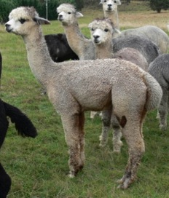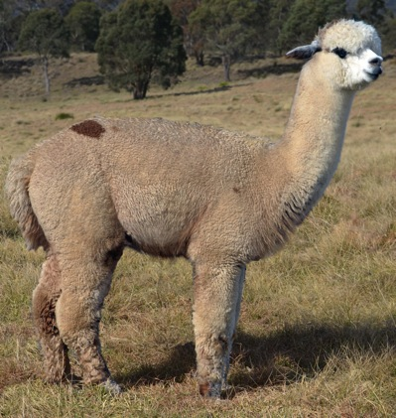

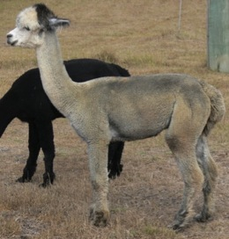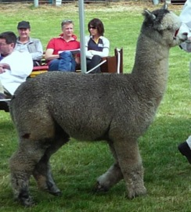

It is always a good idea to remind yourself of the difference made by fleece to your impression of an animal. We once had two young males dismissed for having bad legs and another passed only after investigation. Another breeder kindly trimmed the fleece on the front legs of two of them for us. They came first and second in their class at the next show. Their legs had not changed at all, only their fleece.

Everyone responds to "cuteness"—it is built into us. In breeding animals it is quite common that they are bred to be cuter. If you compare Indian cattle (closer to original cattle) to British beef breeds this is easily apparent. The British breeds have shorter heads, little ears, and compact bodies with shorter legs, lower tail set. They also live short lives.

Neotany plays a part in making domestic breeds "cute". When you breed for docility or friendliness you select in favour of baby-like traits being retained into adulthood. Dogs bred to have less hunting instinct have floppy ears, like puppies.

The vicuña is a wild and difficult animal. In taming it the South American peoples created the alpaca. Breeding over many generations for a more tractable animal makes one with more baby-like features retained to adulthood. In the famous experiment breeding foxes for friendliness in Siberia, the foxes came to have more baby-like features retained to adulthood and also an array of colours.

Some characteristics may be due to heredity, environment, or age. You may not know.

BREEDING HERE: some examples from one female line
Burning Gold Smokey Delight at six months and at two years

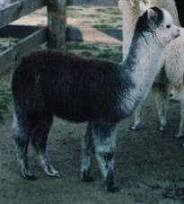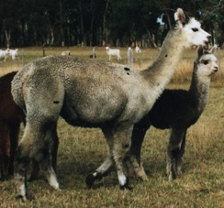

in 2001 and in 2003 at 9 years with Octavia at four months

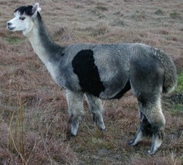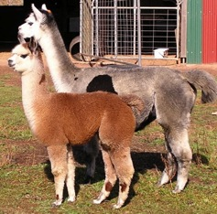

At six months Octavia came third in the National show. Other animals in various lineages here have also had excellent descendants.
Octavia at two years with her first daughter, Colette and at three with her second daughter Titania.

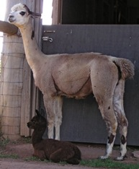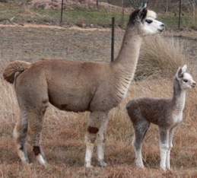

and at six years

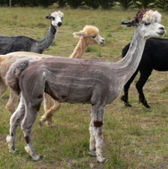

Her daughter Colette at four months and at one year

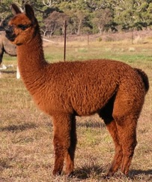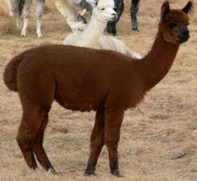

and at four years
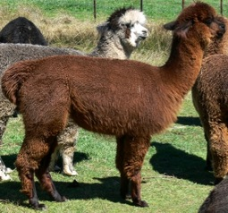

and at six with her five month old granddaughter Gigi, one year in the next photo
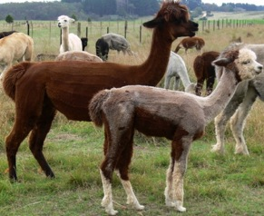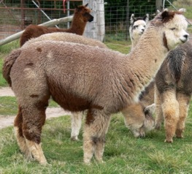

and at two and a half with her son Rigel.
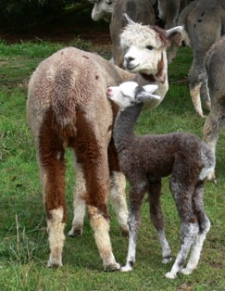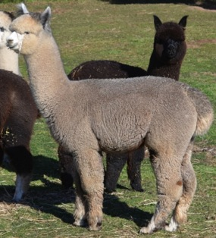

So, the animal on the right is Burning Gold Smokey Delight's great-great-grandson at seventeen months
A different daughter of Smokey Delight at eight years (I don't have an early photo) and her daughter from 2003.

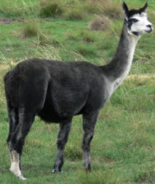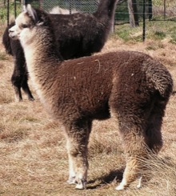

That daughter at three years and at eight years.
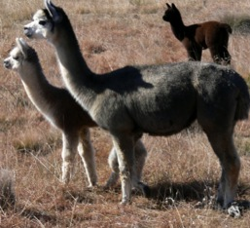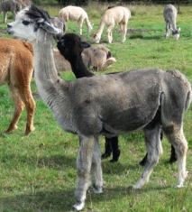

That daughter's daughter as a yearling, and her son.
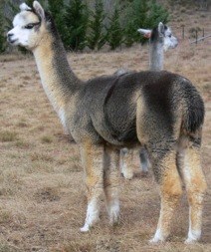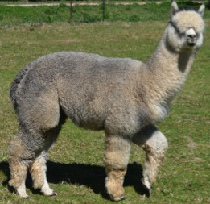

So, again, the animal on the right is a great-great-grandson of the original Burning Gold Smokey Delight.

CHOOSING YOUR ANIMALS
Let's say you have gone to a breeder and are standing amidst a lot of alpacas and certain of them are available for sale.

I read an article recently that explained that when you bought alpacas you were buying animals the seller had culled. This is not at all true in the way that you might think. In the first place, many breeders have different values. The most obvious is interest in colour. In the second place, breeders do not necessarily know which are best or which will be best in the future. And, finally, many breeders do offer their best animals for sale. We have. In some years we sold all our young stock. We at times advertised the animals we thought best in a drop. And, when we decided to keep an animal the reason was not necessarily to do with quality.

In recent years we were less likely to sell our best, but amongst our best were animals (and their descendants) who had failed to sell when advertised. Many of our most useful animals were offered for sale at modest prices. I'm sure other breeders have had similar experiences.

If you go to a dispersal sale you will be able to choose any, but you may not have much information.

Try to be clear about what you want. If price is your first consideration, make it clear. If you are prepared to spend and you have evidence that the animals will be part of a serious breeding plan, then make that clear. If you really want pets, make it clear. But asking for high quality, young, particularly pretty, cheap animals that will guard sheep, be gentle with the children, be attractive still when you want to sell them, and be able to be bred when you are interested, is not helpful.

If you want show animals then you would buy show animals or females and males who have produced show animals. However, consider what has gone into the process of preparing the animals for show and whether want to do that and are willing to make the continuing effort to make progress.

Also remember that animals picked out of the paddock in the morning and shown that day do not present the same as animals who have been confined to small areas for as long as several months before a show to keep them clean and make them calmer when at the show. Clean fleece looks and feels much better than dirty fleece; well-timed clipping might improve the animal's presentation. And, a calm, obedient animal makes a good impression, even if the animal is not naturally calmer and sweeter than others.

Once you have good males your life changes. You can then buy any female you like and figure you can handle any needed improvement.

SHOWING AND BREEDING

If you have some experience of the show ring you will focus on those alpacas that suit the judging standard. This is after all what you are supposed to do.

Most very good animals are now also show quality, but this is partly a sort of convergence. The showy characteristics come with the package because this is how people have been breeding. You would think that standards for showing should set the direction of your breeding securely, but it is probably wise to be aware that show standards change and that they are not always meaningful. Also, show standards have lead to problems with other animals.

In any form of showing, judges and competitors have to have easily observable features they can use to discriminate between entries. It is inevitable that some of these will have little meaning outside the show ring. Showing anything is like that.

Personally I find it doubtful, for example, that "fleece architecture" means anything in processing fleece, or that it is correlated with density and/or fineness. It is pretty and easy to see and assess. There is some old idea that nice tidy staples don't tangle in processing as much as fleece with cross-fibring. A moment's thought about processing should dispel this preconception. As for the idea that the more similar the fibres are the better they will crimp up together into staples doesn't actually seem to be true, from experience.

Take a handful of fleece, brush it—this is what you spin. You have to brush dense, well-defined staples longer to get rid of them. You can't spin staples. By the time the commercial processor has picked and washed fleece there are no staples. Crimp is there in the individual fibres, but it might not resemble the crimp in the staple. Processors may prefer clear crimp because they feel it is correlated with evenness, but processing takes the fleece that was organised while on the animal, separates it totally into individual fibres, and then re-organizes it.

How much of the standard for judging fleece is genuinely tested rather than based on ideas? It may seem logical that more fleece will fit on the animal if it is "organized" or that it is going to be finer if more closely packed, but is this real or just deceptively logical?

We humans like "structured", "uniform", "organized", "orderly" and so on, better than "random", "irregular", "chaotic", "messy".

I love pretty fleece with fine, deep crimp and little staples. I like looking at it when I spin. I can say that fleece that is particularly fuzzy when brushed out spins differently and makes different yarn than fleece that is relatively smooth when brushed out. The fuzzy fleece is easier to spin, much as tussah silk is easier than cultivated silk. The fleece with broader crimp is harder to spin when short and makes a limper yarn, but this limpness might well suit a textile that is supposed to drape. The diameter of the staples doesn't seem to matter.

Style is useful in determining where on the animal the better fleece starts and stops, but doesn't seem to help that much when comparing one animal to another.

Although it is important to keep up with showing and be aware of standards, it is also a good idea to keep in your herd or select for purchase animals that may not match these standards but have other, valuable characteristics. Some of these may be animals that display an extreme trait. Breeding with these may keep you competitive when show standards change.

Over time you come to understand what your animals do. Matings to one male may produce females that are ideal to mate to another male, while the other order does not work as well. Some matings work particularly well. For fleece I feel we have done better with matings of 0% to around 3-4% (sharing one grandparent or some more distant relatives) inbreeding coefficient than higher.

If you close breed you limit your options later.

You need more than a few females in order to do any serious breeding. This is a signficant challenge. Because alpacas are usually sold one by one it is difficult for one person or one couple to manage care and sales of a large enough group to make progress. But judgements based on what has happened with a few matings are not reliable.

You may lose advantage with a mating made for a particular reason but regain it with a later mating. For example, you can manipulate style to some extent with changing fleece length. If you use a male who makes longer fleece over a female with pretty but short fleece, the style and fineness may not be there in the offspring if the fleece is long, but if you then put a male who makes shorter fleece over that offspring you can recreate the fineness and style.

There are also some factors that at times have an unusually large effect. Some animals have fleeces that stay about the same in quality from their second or third fleece on. This seems to be a separate item and can be bred for. An example here is Forestglen Platinum. It even appears in certain lineages when neither parent shows it. It is an extraordinarily valuable trait.

THE PRODUCT

How much weight should you give to the animal's appearance?

I have heard people dismiss beauty in livestock—what does it matter, after all, what the animal looks like? You shear it and sell fleece: anything else is to appeal to a pet market or shows. A visit to a cattle sale will quickly educate you. Commercial farmers like their animals to look right. They are proud of them. You might think that a colour fault wouldn't matter, but even buyers of steers for meat may pay more for solid black and reject an animal with the tiniest white spot.

So, the animal will always remain a product, even if there were a good market for fleece.

How much weight do you give to the animal's fleece and to which qualities?

You can look at fleece production from different angles depending on what you do. A processor doesn't care how much fleece your alpaca cuts or whether the fleece goes off at the shoulder, only about the quality and uniformity of what he pays for. Likewise, he is not concerned with single fleeces. Because it is a bale, the standard deviation may be higher than what a breeder wants in an individual fleece. The fleece buyer may mix bales of different fineness. To the breeder it matters how many animals it takes to produce so many kilos. The actual, usable fleece weight is important, so uniformity over the animal is important. To the processor the animal's appearance does not matter, but to the breeder and judge it does. When you are selling an animal the fleece test matters more than it does in the halter class in the show ring.

That will leave you puzzled as to what you should concentrate on! In choosing animals perhaps try for balance, but keep an open mind about acquiring animals who offer something special even if in other areas they may seem a bit behind. Sometimes you find something particular that is special to you. When you are extremely keen on something you might do better with it. If you really love black you may do better breeding black than if you decide to breed white because the fleece will theoretically be more usable in the future.

FINALLY

Luck with buying animals well is important, but even if you start small and with a limited budget, if you breed them well you can make an excellent herd of alpacas. You don't improve your herd most effectively by buying and selling: you do it by breeding the females so as to raise the middle level of your herd. And, yes, you breed them well by selecting the best males for your females. You may do this by mating them all to a succession of sires, or by choosing different sires for different animals. But the most important thing is to recognize your luck. When you make a very good animal, don't worry too much about the quality of the parents. Lucky accidents are what make improvement possible. Make the most of them.

Remember that the world your animals live in is not the business world or the social world in which you can push here or there to get your way or ignore a complaint until it disappears. In the natural world it rains or it doesn't rain. You can't convince the sky to rain or pretend it hasn't rained or make it rain by saying it has. You can't raise the temperature 5 degrees by adjusting the thermometre. You have to take what you are given and cope.

